

**Safe Deposit Locker Policy**

Deposit & Liability Management

5th floor, CHQ

MA Road Srinagar.

dlm@jkbmail.com

Policy for Safe Deposit Locker

23-06-2020

**Document Control**

|  |  |  |  |
| --- | --- | --- | --- |
| Title | **Safe Deposit Locker Policy** | Version No: | **5.0** |
| Created By | Strategy & Partnerships | Date of Creation | 27.08.2007 |
| Date of Last Review | 10.06.2022 |
| Reviewed By | Deposit & Liability Management | Current Review Date | 10.06.2024 |
| Next Review Date | 09.07.2026 |
| Reviewed By | Integrated Risk Management Committee (IRMC) | Date | 04.06.2024 |
| Approved By | BOD | Date | 09.07.2024 |

**Version Control**

|  |  |  |
| --- | --- | --- |
| S.No | **Version Number** | **Version Date** |
| 1 | Safe Deposit Locker Policy (1.0) | 27.08.2007 |
| 2 | Safe Deposit Locker Policy (2.0) |  |
| 3 | Safe Deposit Locker Policy(3.0) |  |
| 4. | Safe Deposit Locker Policy(4.0) | 10.06.2022 |
| 5. | Safe Deposit Locker Policy(5.0) | 09.07.2024 |

**Policy Governance**

|  |  |
| --- | --- |
| Frequency of review | Two years |
| Last reviewed on | 10.06.2022 |
| Approval path | ORMC/IRMC – Board |
| Supersedes | 10/06/2022 |

Table of Contents

|  |  |  |
| --- | --- | --- |
| S.NO | Contents | Page No |
| 1 | Introduction | 5 |
| 2 | Objectives | 5 |
| 3 | Scope and Applicability | 5 |
| 4 | Customer due diligence (CDD) | 8 |
| 5 | Locker allotment | 8 |
| 6 | Locker Agreement | 8 |
| 7 | Locker Rent | 9 |
| 8 | Security of the Strong Room/Vault & Locker standards | 9 |
| 9 | Operation of the Locker | 10 |
| 10 | Nomination Facility | 11 |
| 11 | Reporting of deceased claims | 18 |
| 12 | Notice of claims of the other persons/court orders | 18 |
| 13 | Surrendering of the locker | 18 |
| 14 | Closure and Discharge of Locker items | 19 |
| 15 | Safe deposit of Articles | 21 |
| 16 | Free visits by the locker hirer | 21 |
| 17 | Service Charges/Size of Lockers | 21 |
| 18 | Liability of the Banks | 22 |
| 19 | Risk management, Transparency & Customer guidance | 22 |
| 20 | Secrecy & confidentiality | 23 |
| 21 | Disclosure | 23 |
| 22 | Ownership and Review | 23 |
| 23 | Annexures |  |

Glossary

|  |  |
| --- | --- |
| Abbreviation/Acronym | Explanation |
| BIS | Bureau of Indian Standards |
| BSD | Business Support Division |
| CDD | Customer Due Diligence |
| CHQ | Corporate Headquarters |
| CCTV | Close Circuit Television |
| GST | Goods & Service Tax |
| HUF | Hindu Undivided Family |
| KYC | Standard Operating Procedure Know Your Customer |
| OVD | Officially Valid Documents |
| S&BD | Strategy and Business Development |
| SOP | Standard Operating Procedure |
| DLM | Deposit Liability Management |

1. **Introduction**

Safe deposit locker facility to the customers plays a pivotal role in meeting the growing demands of the customers regarding facility beyond conventional banking, expanding the customer base and augmenting the non-interest income of the bank. The relationship between the banker and the customer, who has been provided with the locker facility, is that of a lessor and lessee. Lockers are meant for safe keeping of valuables like jewellery and documents as they offer protection against burglary and theft. Lockers are considered to be relatively safe in situations like civil commotion and unrest etc.

Safe deposit locker facility is one of the important ancillary services extended by the bank at large number of Branches across India. The locker units are leased out to customers who maintain a Savings Bank Account/Current Deposit Account with any Branch. The Safe Deposit Locker Policy encompasses all the latest guidelines issued by the RBI in terms of Master Circular on Safe Deposit Lockers/Articles circular no. [RBI/2021-2022/86DOR.LEG.REC/40/09.07.005/2021-22](https://www.rbi.org.in/Scripts/NotificationUser.aspx?Id=12146&Mode=0) dated 18.08.2021

1. **Objectives**
2. To devise standardized and uniform procedure for smooth locker management.
3. To adhere to all the guidelines issued by the regulator viz-a-viz locker management.
4. To make locker facility an attractive offering to the customers of the Bank.
5. **Scope and Applicability**

The locker can be hired by individuals including illiterate persons, blind and visually challenged persons, two or more persons with mode of operation as jointly or ‘either or survivor’ or ‘former or survivor’ or ‘anyone or survivor’.

It can also be availed by Limited Companies, Partnership firms, Clubs, Societies, Associations, Trusts etc.

Note: A minor cannot hire a locker as any contract with minor is null and void.

* 1. **Individual/Two or more persons jointly/two or more persons with ‘either or survivor’ or ‘former or survivor or ‘anyone or survivor’ or ‘latter or survivor’ clause**

While letting out a locker to an Individual/two or more persons jointly/two or more persons with “either or survivor” or “former or survivor or “anyone or survivor’ or ‘latter or survivor’ clause, he/she/they shall affix his/her/their signatures on the Locker Agreement in the presence of an authorised officer and three copies of passport size photographs of locker hirer(s) shall be obtained and pasted on Locker Agreement.

* 1. **Illiterate persons**

While letting out a locker to an illiterate person, his/her left/right hand thumb impression shall be taken on the Locker Agreement in the presence of an authorised officer and witnessed by two persons known to the bank. Three copies of passport size photographs, of such lessee bearing his/her left/right hand thumb impression shall be obtained and pasted on Locker Agreement.

* 1. **Blind/visually challenged persons**

The facility of locker may be provided to the visually impaired person (literate as well as illiterate) as per [RBI/2015-16/59DBR No.Leg.BC. 21/09.07.006/2015-16](https://www.rbi.org.in/scripts/NotificationUser.aspx?Mode=0&Id=9863#a4) dated 01.07.2015 as under:

* + 1. Locker facility may be allowed jointly with a person without any visual impairment known / related to him / her (the visually impaired person intending to take locker on lease) and operation of such locker shall be permitted jointly. All the documents relating to leasing of locker shall be executed jointly.
    2. Locker facility may be allowed singly in the individual name of the visually impaired person. However, operation of such locker shall be permitted in the presence of one literate witness with no visual impairment who shall be designated by the lessee at the time of execution of Locker Agreement. The lessee (the visually impaired person) may designate maximum three witnesses at the time of executing the Locker Agreement. The signature of the witness shall also be obtained along with the signature / thumb impression of the visually impaired lessee at the time of operation of locker.
    3. The visually impaired customer (lessee of locker) may change the witness/(es) subsequently. Until and unless the situation warrants, frequent changes in the witness (es) should be discouraged.
    4. It should be ensured that the designated witness(es) is / are customer(s) of the Branch having KYC compliant accounts.
    5. Visually impaired lessee can also appoint a person who is literate with no visual impairment as an authorized person for operating the locker. The lessee must call at the Branch for appointing the authorized person.
    6. The words BLIND/VISUALLY IMPAIRED should be written on top of the Locker Agreement and also noted in E-locker Application.
  1. **Limited Company, Club, Society, Association, Trust etc.**

While letting out a Locker to a Limited Company, Club, Society, Association or Trust following procedure shall be adopted:

* + 1. Duly authenticated copies of documents providing for constitution of the entity (Memorandum of Association, Articles of Association, Trust deed etc.) be obtained.
    2. Board resolution(s) of the managing committee etc. conferring express powers on:-

1. Specific person/s to apply for availing locker facility, and,
2. Specific person/s for execution of necessary documents and operation of the locker, be obtained
   * 1. It is to be ensured that the authority to operate the locker is given to the authorized person/s in the resolution in terms of the constitutional documents and the resolution is signed by the persons authorized to do so.

In case of unincorporated association of persons or a body of individuals, besides the resolution of the managing body of such associations or body of individuals, a Power of Attorney duly registered by the registering authority (Sub-Registrar) must be obtained authorizing specific person/s to operate the locker on its behalf.

In every case, the KYC requirements must be strictly complied with.

**Note:** Unregistered trusts/ partnership firms shall be included under the term ‘unincorporated association’.**”** Attested/ duly authenticated copy of the partnership deed must be obtained in case of partnership. Partnership deeds in the Uts of J&K and Ladakh do not require to be registered, the notarization of same shall be sufficient.

* 1. **Changing of the Status of the locker**

Where an individual lessee desires to convert his/her account into a joint account, the old locker standing in his/her name must be first surrendered by him/her and a fresh one issued or the same be re-allotted in the joint names, on completion of all the required formalities. Specific instructions regarding mode of operation and access to lockers must invariably be obtained from the joint lessees on Locker Agreement and entered in E-locker application. In such cases, the advance rent for the surrendered locker, for the unexpired period, is to be adjusted towards the rent of the new locker.

* 1. **Authority of Operation to a third person**

Appointment of a third person for operation of the allotted locker by locker hirer(s) shall be allowed in exceptional cases only. In such case/s the locker hirer (s)/ lessee(s) shall be required to execute a Power of Attorney duly registered by the registering authority (Sub-Registrar) for operation of the Locker capturing all requisite details including the specimen signature of the Attorney.

The Power of Attorney for operation of the Locker by a third person, besides authorizing such third person to operate the locker, shall inter-alia invariably contain following clauses:-

* + 1. The Principal (s)/hirer (s) does/do hereby expressly state/s that during the period this Special Power of Attorney continues to be in force, the Principal(s)/(Locker allottee(s) /Lessee(s)) shall have no power to operate the said locker allotted/ licensed out in his/her/their favour.
    2. The Principal (s)/hirer (s) does/do hereby expressly state/s that the power vested with the attorney holder shall stand revoked and the Special Power of Attorney shall stand cancelled immediately after the Principal(s)/(Locker allottee(s) /hirer(s)) intimate/s so to the concerned Branch of the Bank in writing about revocation of attorney. However, all the acts performed by the Attorney in pursuance of the powers conferred till actual receipt of such revocation letter shall be binding on the Principal (s)/hirer (s) and shall not be contested for any reason whatsoever.
    3. The Principal (s)/hirer (s) does/do hereby expressly state/s that the Bank shall not be responsible to any person for any loss whatsoever caused by allowing the operation of the allotted/leased out locker after the death of the Principal(s)/hirer(s) or any of them unless the Bank has been given notice of such death.
    4. Authorization by way of Power of Attorney in favour of minors and blind persons, and by trustees in favour of third persons, shall in no case be accepted.

1. **Customer due diligence (CDD)**

4.1 The existing customers of a bank who have made an application for locker facility and who are fully compliant with the CDD criteria under the Master Direction – Know Your Customer (KYC) Directions, 2016 (as updated from time to time) may be given the facilities of safe deposit lockers/ safe custody article subject to on-going compliance.

4.2 Customers who are not having any other banking relationship with the bank, may be given the facilities of safe deposit locker / safe custody article after complying with the CDD criteria under the Master Direction – Know Your Customer (KYC) Directions, 2016 (as updated from time to time) and subject to on-going compliance. The due diligence shall be carried out for all the customers in whatever rights and capacities they may be hiring the locker.

4.3 The locker-hirer/s shall not keep anything illegal or any hazardous substance in the Safe Deposit locker. If the Branch suspects the deposit of any illegal or hazardous substance by any customer in the safe deposit locker, the bank shall have the right to take appropriate action against such customer as it deems fit and proper in the circumstances.

1. **Locker Allotment**

Branches should maintain a waiting list for the purpose of allotment of lockers. All applications received for allotment of lockers should be acknowledged and given a wait list number if the locker is not available. Branches shall enter in the E-locker application, the name, address & contact details of the person who is on the waiting list for allotment of locker. Whenever, any existing customer vacates the locker, Branch shall approach/contact wait listed customer on first come first serve basis, thereby maintaining transparency. The lockers should be allotted by the Branches on first cum-first-serve basis. The lockers allotted to the staff at concessional rates should not exceed 33% of total locker inventory of the Branch.

Branches shall also display availability of Locker facility along with charges structure at a conspicuous place in the Branches.

In case Branch’s available inventory is near to exhaustion, a request for installation of new locker cabinet/s shall be forwarded to Zonal Offices immediately (subject to demand/space availability) so that no customer is kept waiting for locker allocation. Zonal office shall take a periodic review of their branches and ensure that adequate lockers are available at all locations as per demand provided sufficient space is available for housing the locker cabinet/s.

1. **Locker Agreement**

The locker hirer is required to execute Locker Agreement on non-judicial stamp paper as per the norms applicable. All instructions like mode of operation, nomination etc are to be covered in the Locker Agreement, as per **Annexure I**

A copy of the Locker Agreement, duly executed, shall be provided to the locker hirer at the time of allotment of the locker. (In case of existing hired lockers, the same can be provided to the locker hirer on demand).

1. **Locker Rent**

7.1 Branches may face situations where the locker-hirer neither operates the locker nor pays rent. To ensure prompt payment of locker rent, Branches shall, at the time of allotment, obtain fixed deposit as security for lockers, which should cover 3 years rent and the charges for breaking open the locker in case of an eventuality. Thus, the Branches shall obtain a fixed deposit for an amount equivalent to break open charges & 3 years rent plus applicable GST as security from the locker holder in addition to normal rent. However, Branches shall not insist on such Term Deposits from the existing locker holders or those who have satisfactory operative account. The packaging of allotment of locker facility with placement of term deposits beyond what is specifically permitted above will be considered as a restrictive practice. (RBI circular RBI/2021-2022/86DOR.LEG.REC/40/09.07.005/2021-22 dated August 18, 2021)

7.2 If locker rent is collected in advance, in the event of surrender of a locker by a customer, the proportionate amount of advance rent collected shall be refunded on pro rata basis to the customer on day count basis without GST.

7.3If there is any event such as merger / closure / shifting of branch warranting physical relocation of the lockers, the Branch shall, in consultation with the concerned Zonal Office publish notice in two newspapers (including one local daily in vernacular language) in this regard but intimate the locker holder at least two months in advance giving them option either to agree with change in location or surrender of the locker. In case of unplanned shifting due to natural calamities or any other such emergency situation, Branch shall make efforts to intimate their customers suitably at the earliest.

1. **Security of the Strong Room/Vault & Locker Standards**

8.1 Bank shall take necessary steps to ensure that the area in which the locker facility is housed is properly secured to prevent criminal break-ins. The risks of accessibility to an allotted locker from any side without involvement of the locker-hirer concerned may be assessed by the Branch and kept on record and bring under the notice of concerned zonal office for further action. Branches shall have a single defined point of entry and exit to the locker room/vault. The place where the lockers are housed must be secured enough to protect against hazard of rain / flood water entering and damaging the lockers in contingent situations. The fire hazard risks of the area should also be assessed and minimized. The BSD Department of the concerned Zonal Office shall conduct necessary engineering / safety verification regularly at the Branches to identify the risks and carry out necessary rectification

8.2 The electronically accessed lockers provided to the customers should be made fully aware of the safety and security features of such lockers satisfying appropriate industry standards. In case the lockers are being operated through an electronic system, the bank shall take reasonable steps to ensure that the system is protected against hacking or any breach of security. The customers’ personal data, including their biometric data, shall not be shared with third parties without their consent.

Further, it shall be ensured that the electronically operated lockers are compliant with the Cyber Security Framework prescribed by the Reserve Bank. The system should be capable of maintaining unalterable log of locker activities.

8.3 The area housing the lockers should remain adequately guarded at all times. The Branch shall restrict any unauthorized entry and create digital record of access to locker room with time log in the e-Locker application. Branches shall cover the entry and exit of the strong room and the common areas of operation under CCTV camera and preserve its recording for a period of not less than 180 days. In case any customer complaints to the bank that his/her locker has been opened without his/her knowledge and authority, or any theft or security breach is noticed/observed, the Branch shall preserve the CCTV recording till the police investigation is completed and the dispute is settled.

8.4 The security procedures shall be well-documented and the staff concerned shall be properly trained in the procedure. The internal auditors shall verify and report the compliance to ensure that the procedures are strictly adhered to.

8.5 All the new mechanical lockers to be installed by the banks shall conform to basic standards / benchmarks for safety and security as prescribed by Bureau of Indian Standards (BIS) or any other enhanced industry standards applicable in this regard.

8.6 Branches shall get the locker keys embossed with the identification code of the Bank/Branches (JKB/SOL ID). An arrangement for installation of necessary machinery at the Branches with the help of the vendor company of the locker cabinets/Business Support Division CHQ shall be made for this purpose. In case the embossing has not been done, Branches shall get the embossing done on urgent basis. Branches shall advice all the locker hirers about the embossing of the locker keys. It may also be ensured that the identification code is embossed on the locker keys in presence of the locker hirer only. Further, the custodian of the locker shall, regularly/periodically, check the keys maintained in the branch to ensure that they are in proper condition. Branches shall permit the locker-hirer to operate the locker only with the key provided by the bank, although there is no restriction in allowing the customer to use an additional padlock, if there are such provisions in lockers.

1. **Operation of the Locker**

The Bank has introduced Electronic Locker Services Manager (e-Locker). The application has been integrated with the CBS of the Bank to facilitate the operative levels in smooth allocation and maintenance of the locker facilities with minimum manual interventions.

9.1 The locker hirer and/or the persons duly authorized by him/ her only shall be permitted to operate the locker after proper verification of their identity and recording of the authorization by the official concerned of the Branch. The Branch shall maintain a record in the e-Locker application, of all individuals, including the locker-hirers, the date and time (both check-in and check-out time) on which they have opened the locker vault and obtain their signature. The ingress and egress register for access to Vault Room by locker-hirers or any other individual including the banks’ staff shall be maintained to record the movement of individuals in the Vault Room area with their signatures at appropriate place in the records.

9.2 The locker custodian authorizing the locker-hirer/operator of the locker to open the locker, shall not remain present after unlocking the first lock. The Branches shall ensure that there is adequate privacy to the locker-hirers in the operations when customers access the lockers at the same time.

9.3 Bank shall send an email and SMS alert to the registered email ID and mobile number of the customer before the end of the day as a positive confirmation intimating the date and time of the locker operation and the redressal mechanism available in case of unauthorized locker access.

9.4 There shall be a system of inter change of locks whenever the locker is surrendered by the hirer. The keys of vacant lockers shall be kept in sealed envelopes. The duplicate master keys shall be deposited with another branch of the bank. There shall be proper record of joint custody of master keys. The concerned Zonal Heads shall conduct surprise verification of surrendered/vacant lockers and their keys by an officer of the bank who is not connected with their custody and proper record shall be maintained as a proof of such verification.

9.5 Branches shall ensure that the Locker Register and the Locker Key Register are maintained in the e-Locker application. The Locker Register in the application shall be updated in case of any change in the allotment with complete audit trails.

9.6 The Locker custodian at the Branch shall check whether the lockers are properly closed post locker operation. If the same is not done, the lockers must be immediately closed, and the locker-hirer be promptly intimated through e-mail, if registered or through SMS, if mobile number is registered or through letter so that they may verify any resulting discrepancy in the contents of the locker. The Locker custodian shall record in the register, the fact of not closing the locker properly and its closure by the bank with the date and time. Further, the custodian of the locker room shall carry out a physical check of the locker room at the end of the day to ensure that lockers are properly closed, and that no person is inadvertently trapped in the locker room after banking hours.

1. **Nomination Facility**

The Bank shall offer nomination facility in case of safe deposit lockers and safe custody of articles in accordance with the provisions of section 45ZC to 45ZF of the Banking Regulation Act, 1949 and Banking Companies (Nomination) Rules, 1985. Branches are advised to refer to guidelines w.r.t Nomination facility issued vide circular no: 125 (Circular Id 9301) dated June 04, 2018 issued by erstwhile S&BD for necessary guidelines and prescribed formats and Circular no 731 dated January 11 2024 issued by CBO wherein Branches were directed to obtain nomination details from all locker customers (existing as well as new) or to obtain nomination rejection letter/mark the same on agreement/AOF if customer refuses to provide the nomination. Branches shall provide a proper acknowledgment of the receipt of duly completed form of nomination, cancellation and / or variation of the nomination. Such acknowledgement shall be given to all the customers irrespective of whether or not it is demanded by them.

Nomination forms SL1, SL1A, SL2, SL3 & SL3A are enclosed as Annexure VI. Following operational measures in respect of safe deposit locker should be noted:

**10.1** **Settlement of claims in case of death of a customer & access to the articles in the lockers**

10.1.1If a sole locker hirer nominates an individual to receive the contents in the locker in case of his death, the Branches shall give such nominee access to the locker with liberty to remove the contents therein but only after making inventory of the contents of locker in the prescribed manner, ensuring genuineness of the death certificate of locker hirer and satisfying itself about the identity of the nominee.

In case the locker was hired jointly with the instructions to operate it under joint signatures, and the locker hirer(s) had nominated any other individual(s) to receive the contents in the locker in the event of death of any of the locker hirers, the Branch shall give the survivor(s) and the nominee(s) joint access to the locker and the liberty to remove the contents after taking inventory in the prescribed manner.

In case the locker was hired jointly with survivorship clause and the hirers instructed that the access of the locker should be given to “either or survivor”, “anyone or survivor” or “former or survivor” or according to any other survivorship clause permissible under the provisions of the Banking Regulation Act, 1949, the banks shall follow the mandate in the event of death of one or more of the joint locker-hirers.

10.1.2 Banks are not required to open sealed/closed packets found in locker while releasing them to the nominee or nominees and surviving hirers. Description of the sealed/closed packet(s) should however be mentioned in the inventory.

* + 1. Section 45ZE of the B.R Act, 1949 does not preclude a minor from being a nominee for obtaining delivery of the contents of a locker. The responsibility of the banks in such cases is to ensure that while removing the contents of the locker on behalf of the minor nominee, the articles must be handed over to a person who is legally competent to receive the articles on behalf of the minor. Further, the Branches should prepare an inventory of the articles in the presence of two independent witnesses, one being an officer of the Branch not associated with the locker facility and the other being either the minor nominee or an individual receiving the articles on behalf of that minor.
    2. The Branches shall obtain a separate statement from the nominee (claimant) or the person competent to receive articles on behalf of the minor, as the case may be, that all the contents in the locker or in the safe custody of the bank, as the case may be, have been received and the locker is empty and they have no objection to allot the locker to any other customer as per norms.
    3. Branches, shall, before permitting the removal of the contents of any locker by any nominee or jointly by any nominee and survivors as aforesaid, prepare an inventory of the contents of the locker which shall be signed by such nominee or jointly by such nominee and survivors and shall deliver a copy of the said inventory so prepared to such nominee or nominee and survivors. On removal of the contents of any locker by any nominee or jointly by any nominee and survivors as aforesaid, the liability of the Bank in relation to the contents of the locker shall stand discharged.
    4. Branches shall ensure the following before giving access to the contents to nominee / survivor:

1. Exercise due care and caution in establishing the identity of the survivor(s) / nominee(s) and the fact of death of the locker hirer by obtaining appropriate documentary evidence.
2. Make diligent efforts to rule out that there is not any order or direction from Courts/Forums restraining it from giving access to the locker of the deceased; and
3. Make it clear to the survivor(s) / nominee(s) that access to articles in the locker / safe custody articles is given to them only as a trustee of the legal heirs of the deceased locker hirer i.e., such access given to them shall not affect the right or claim which any person may have against the survivor(s) / nominee(s) to whom the access is given.
   * 1. Branches shall settle the claims in respect of deceased locker hirers and shall release contents of the locker to survivor(s) / nominee(s), as the case may be, within a period not exceeding 15 days from the date of receipt of the claim subject to the production of proof of death of the locker hirer and identification of the claimant(s) with reference to nomination, to the best of its satisfaction.
     2. While giving access to the survivor(s) / nominee(s) of the deceased locker hirer / depositor of the safe custody articles, banks may avoid insisting on the production of succession certificate, letter of administration or probate, etc., or obtain any bond of indemnity or surety from the survivor(s)/nominee(s), unless there is any discrepancy in nomination.

Similar procedure shall be followed for the articles under safe custody of the bank.

Further, in case the nominee(s) / survivor(s) / legal heir(s) wishes to continue with the locker, Branch may enter into a fresh contract with nominee(s) / survivor(s) / legal heir(s) and also adhere to KYC norms in respect of the nominee(s) / legal heir(s).

**10.2 Illustrations**

Following examples would make the understanding easy: -

1. **Safe Deposit Lockers Operated Singly**
2. **Safe Deposit Lockers with Nomination:**

The nominee will be allowed to access the locker and remove the contents on verification of identification (by submission of officially valid documents (OVD) under KYC norms) and verification of proof of death of locker hirer. Before permitting the nominee to remove contents of the Safe Deposit Locker, the bank would prepare an inventory of the articles in the presence of nominee(s) and two independent witnesses. Form for taking inventory is enclosed as **Annexure –5**

1. **Safe Deposit Lockers Without Nomination:**

Legal heir(s) of the deceased locker hirer or a person mandated by the legal heir(s) will be allowed to access the locker and remove the contents on verification of proof of death of locker hirer. The legal heir(s) will have to produce documents to establish his /her/ their identity. Before permitting legal heir(s) to remove contents of the Safe Deposit Locker the bank would prepare an inventory of the articles in the presence of legal heir(s)/mandate holder and two independent witnesses. Form for taking inventory is enclosed as **Annexure – 5**.

1. **Joint Safe Deposit Lockers operated jointly:** 
   * 1. **Safe Deposit Lockers with Nomination:**

a. In the event of the death of one (or more but not all) of the joint locker hirers the nominee(s) will be jointly allowed to access the locker and remove the contents on identification and verification of proof of death of the locker hirer(s) along with the surviving hirer(s).

* 1. In the event of death of both / all joint locker hirers the nominee(s) will be allowed to access the locker and remove the contents on establishing his/her/their identity and verification of proof of the death of the hirers.
  2. Before permitting surviving hirer(s) and/or nominee(s) to remove contents of the Safe Deposit Locker, the bank shall prepare an inventory of the articles in their presence along with two independent witnesses as per **Annexure 5**

1. **Safe Deposit Lockers Without Nomination:** 
   1. In the event of death of one (or more but not all) of the locker hirers, the surviving hirer(s) and legal heirs of the deceased hirer (or a person mandated by them) would be allowed to access the locker and remove the contents on verification of authority of legal heirs and proof of death of the hirer.
   2. In the event of death of both / all the joint locker hirers, all the legal heirs (or any one of them as mandated by all legal heirs) would be allowed to access the locker and remove the contents on verification of authority of legal heirs and proof of death of the locker hirers.
   3. Before permitting surviving hirers and mandated legal heir(s) to remove contents of a Safe Deposit Locker, the bank shall prepare an inventory of the articles in the presence of surviving hirers, mandated legal heir(s) and two independent witnesses as per **Annexure 5(a)**.
2. **Joint Safe Deposit Lockers With Mode of Operation as “Either Or Survivor”/“Former Or Survivor”/ “Anyone Or Survivors”/ “Latter Or Survivor”:** 
   * 1. **Safe Deposit Lockers with Nomination:**

Where there are joint locker-hirers having a contract of hire with survivorship clause such as ‘either or survivor’, ‘anyone or survivor’ etc., but the locker is not to be operated jointly, access to the locker may be given only to the survivor in case of death of one of the hirers.

* + 1. **Safe Deposit Lockers Without Nomination:**

1. In the event of death of one (or more but not all) of the joint hirers, the surviving hirer(s) will be allowed to access the locker and remove the contents on verification of proof of death of the joint hirer(s).
2. In the event of death of all the locker hirers, all the legal heirs of the deceased joint hirers (or any one of them as mandated by all legal heirs) would be allowed to access the locker and remove the contents on verification of the authority of legal heirs and proof of death of the locker hirers. Before permitting the surviving hirers/legal heir(s) to remove contents of a Safe Deposit Locker, the bank shall prepare an inventory of the articles in the presence of surviving hirers/legal heirs and two independent witnesses as per **Annexure 5(a)**
3. Settlement of Claims for Various Types of Operational Instructions in Safe Deposit Lockers With Nomination.

|  |  |  |  |  |
| --- | --- | --- | --- | --- |
| Locker in the Name of | Operational Instructions | Nominee | Situation | What is to be done |
| A | Self | X | X dies | A can change the nomination |
| A | Self | X | A dies | X will be given access to the locker and liberty to remove contents |
| A,B | Jointly | X | A dies | B and X will be given access to the locker and liberty to remove contents jointly. |
| A,B | Jointly | X | B dies | A and X will be given access to the locker and liberty to remove contents jointly |
| A, B | Jointly | X | A & B die | X will be given access to the locker and liberty to remove contents. |
| A,B | Jointly | X & Y | A dies | B along with X and Y will be given access to the locker and liberty to remove contents jointly |
| A, B | Jointly | X & Y | B dies | A along with X and Y will be given access to the locker and liberty to remove contents jointly. |
| A,B | Jointly | X & Y | A & B die | X and Y jointly will be given access to the locker and liberty to remove the contents |

1. Settlement Of Claims for Various Types Of Operational Instructions in Safe Deposit Lockers Without Nomination

|  |  |  |  |
| --- | --- | --- | --- |
| Locker in the Name of | Operational Instructions | Situation | What is to be done |
| A | Self | A dies | Legal heirs of A or any of them mandated by any of them. |
| A, B | Either or Survivor | A dies | B will be given access to the locker and liberty to remove the contents. |
| A, B | Either or Survivor | B dies | A will be given access to the locker and liberty to remove the contents. |
| A,B | Either or Survivor | A & B die | Legal heirs of A and B (or any one of them mandated by all legal heirs) will be given access to the locker and liberty to remove the contents. |
| A,B | Jointly | A dies | B and legal heirs of A (or any of them mandated by all legal heirs) will be given access to locker and liberty to remove the contents jointly. |
| A,B | Jointly | B dies | A and legal heirs of B (or any one of them mandate by all legal heirs) will be given access to locker and liberty to remove the contents jointly |
| A, B | Jointly | A & B die | Legal heirs of A & B (or any of them mandated by all legal heirs) will be given access to locker and liberty to remove the contents. |

* 1. **Safe Deposit Locker Procedure In Case There Is No Nomination/ Survivorship Clause:**
     1. On receipt of notice of death of sole hirer or of the last survivor among the joint hirers, the locker shall be sealed with the Bank’s seal and a note to this effect shall be made in the all respective records as well as in the Declaration Card. The Declaration Card should be taken out of card index cabinet and kept carefully in a separate file.
     2. Branches may at their discretion, on production of satisfactory evidence, permit a legal representative of the deceased to inspect the contents of the locker to enable him /her to obtain the necessary succession certificate or any other legal representation.
     3. The legal heirs of the locker hirer shall be advised to furnish the death certificate, and the legal heir certificate issued by the concerned Tehsildar and thereafter the Branch should handover the contents of the locker to the legal heirs or their representatives against an Indemnity Bond to be executed by all legal heirs in favour of the Bank, subject to the following:
     4. The claimants/heirs of the deceased hirer should furnish necessary particulars in the claim format, which is ordinarily obtained in deposit accounts.
     5. A letter should be taken from all the heirs requesting the Bank to open the locker for the purpose of inventory.
     6. Branch should then fix up a date and time for making an inventory and accordingly an inventory may be taken in the prescribed inventory record form in presence of all the heirs/ their duly constituted attorney/ies, two respectable witnesses known to the Branch (should not be employees or ex-employees of the Bank), the valuer, the Safe Deposit Vault Custodian and other officer not connected with locker assignment. After making an inventory, care should be taken to redeposit all the contents in the said locker and to seal it.
     7. Where the legal heirs of the deceased locker hirer are having any dispute or the Branches are not in a position to satisfy itself about the legal heirs of the deceased locker hirer, the person/s claiming the contents of the locker should be asked to obtain succession certificate for the final disposal of the contents.
     8. Branches should forward the claims of the claimants/heirs of the deceased to their respective Law department for opinion to enable them to consider delivering the contents against usual indemnity signed by the claimant/s and one or two surety/ies considered good for the amount involved. On receipt of the approval, the claimant/s should be allowed to remove the contents from the locker after signing an indemnity and a letter of surrender together with the key.
     9. Where an inventory is to be taken in terms of a court order, it should be done in the presence of:
     10. the Court’s representative,
     11. the claimant/s to the contents of the locker held by the deceased hirer,
     12. the valuer and
     13. Two officers of the Branch. The inventory should enumerate the contents of locker and it should be signed by those in whose presence the locker has been opened. The valuer’s assessment of the value of each item of the inventory should be in triplicate, one copy for the Court, the second to the claimant and the third to be retained by Branch for record purpose.

1. **Reporting of Deceased Claims**

Branches shall update through e-Locker application at half-yearly intervals, on an ongoing basis, the details of the number of claims received pertaining to deceased locker-hirers and those pending beyond the stipulated period, with reasons thereof.

Customer Care Department CHQ shall prepare a consolidated report of the details of number of claims received by Branches pertaining to deceased locker-hirers and those pending beyond stipulated period, with reasons thereof. The report shall be presented before the Customer Service Committee of the Board at half yearly intervals, on an ongoing basis. The Committee shall review the settlement of claims report and make suggestions to ensure that the claims are settled as early as possible unless there is any litigation pending before the Courts or any difficulty is being faced in identifying the true claimant with reference to nomination.

1. **Notice of claims of other persons/court orders**

No notice of the claim of any person, other than hirer or hirers of a locker, shall be entertained by the Branch, nor shall the bank be bound by any such notice even though expressly given to it.

Provided that where any decree, order, certificate etc. from a court or any other authority/authorized person relating to the locker or its contents, is produced before a Branch, the Branch shall take due note of it by recording the date and time of its receipt. The matter shall then without any delay, be referred to the Law Department of the concerned Zone for opinion in the matter. The order of the court or other authority/officer shall be kept in a separate file, which shall remain in custody of the Incumbent In- charge/Custodian under lock and key.

If the operation of the locker is advised to be stopped, the date, name of the Court/Authority/Officer and the date and time of the receipt of the Locker be recorded in red ink under the signatures of the custodian, on the relative specimen signature card and caution be marked in E-locker application. In such a case, the locker in question shall be sealed by the Incumbent In- charge to prevent unauthorized operation thereof, during the operation of any such order of the court or other authority/officer. Where the locker cannot be sealed, a blank red slip shall be pasted on it to indicate caution.

The seal of the locker or red slip thereon shall be removed by the Incumbent In-charge only after the original order of the court or other authority/officer is vacated/cancelled /withdrawn/modified etc. and opinion of Law Department of the concerned Zone in the matter is obtained. The date and time of receipt of such order of vacation/cancellation/withdrawal/modification etc. order shall be recorded. If the operation of the locker is advised to be allowed, the date and time of receipt of such order of vacation/cancellation/withdrawal/modification etc. order shall be recorded in blue ink, at all relevant places where mention of the original order was made. The Incumbent shall keep a certified copy of such vacation/cancellation/withdrawal/ modification etc. order on record.

1. **Surrendering of the locker**
   1. After the locker has been surrendered, lock of such locker shall be interchanged, immediately with that fixed to another vacant locker or replaced by a lock from the reserve supply. Where the manufacturers/suppliers’ mechanic is available, inter-change/replacement of lock, may be got done from him, otherwise this work shall be done by an authorised official, in all cases, under the personal supervision of the Incumbent In-charge/Custodian.
   2. On surrender of a locker, the surrender certificate must be obtained from the lessee(s). Necessary cancellation should also be made under authentication of the Custodian.
   3. Immediately after surrender/last operation, locker must be carefully examined by the custodian to ensure that the lessee leaves behind no articles in or outside the locker.
2. **Closure and Discharge of locker items**

This part refers to the breaking open of the locker in a manner other than through the normal access by the customer under any one of the following circumstances:

1. if the hirer loses the key and requests for breaking open the locker at her /his cost; or
2. if the Government enforcement agencies have approached the bank with orders from the Court or appropriate competent authority to seize lockers and grant access to the lockers; or
3. If the bank is of the view that there is a need to take back the locker as the locker hirer is not co-operating or not complying with the terms and conditions of the agreement.

**14.1 Discharge of locker contents at the request of customer**

14.1.1 If the key of the locker, supplied by bank is lost by the locker-hirer, the customer (locker hirer) shall notify the Branch immediately. An undertaking may also be obtained from the customer that the key lost, if found in future, will be handed over to the Branch. All charges including GST for opening the locker, changing the lock and replacing the lost key shall be recovered from the hirer. The charges applicable for replacement of lost keys shall be communicated to the locker hirer.

14.1.2 The opening of the locker has to be carried out by the Branch only after proper identification of the hirer, proper recording of the fact of loss and written authorization by the customer for breaking open the locker. Branch shall also seek permission from the concerned Zonal Office before going ahead with the operation.

14.1.3 The operation shall be done in the presence of the customer/s and an authorized official of the Branch. It has to be ensured that the adjoining lockers are not impacted by any such operations and the contents of the lockers are not exposed to any individual other than the locker-hirer during the break-up or restoration process.

**14.2 Attachment and recovery of contents in a Locker by any Law Enforcement Authority**

14.2.1 In case of attachment of a locker of any customer and seizure of the contents kept therein, by any Agency acting either under the orders of a Court or any other competent authority vested with the power to pass such orders, the Branch shall co-operate in execution and implementation of the orders after seeking permission for the same from the concerned Zonal Office.

14.2.2 The concerned Zonal Office shall verify the attachment order received by the Branch before giving the go ahead to the Branch about the orders and the connected documents received for attachment and recovery of the contents in a locker or articles in the safe custody of the bank. The customer (locker-hirer) shall be informed by letter as well as by email/SMS to the registered email id/mobile phone number that the Government Authorities have approached for attachment and recovery or seizure of the locker or articles deposited for safe custody. An inventory of the contents of locker and articles seized and recovered by the Authority shall be prepared in the presence of such Government Authorities, two independent witnesses and an officer of the Branch and shall be signed by all. A copy of the inventory may be forwarded to the customer to the address available in the bank’s records or handed over to the customer against acknowledgement.

14.2.3 Branches shall also record a video of the break-open process and the inventory assessment, wherever legally permissible, and preserve the video to produce as evidence in case of need in future.

**14.3. Termination of License**

14.3.1 The Bank has the right, in the event of the Customer’s breach of or default under the locker Agreement and/ or the Bank being of the view that the Customer is not co-operating and/or complying with the terms and conditions of the Agreement, a right to terminate the Agreement and the license granted , after issuing to the Customer a prior written notice of not less than 1 (one) month by registered post and also by (i) email where email id of the Customer is available; and (ii) SMS where the mobile phone number of the Customer is available, a Termination Notice as per annexure- VI

14.3.2 Upon receipt of the termination notice, the licensee shall forthwith and before the end of the notice period (one month) surrender and vacate the locker and handover the keys to the Bank.

**14.4 Discharge of locker contents by banks due to non-payment of locker rent**

14.4.1 Branches shall have the discretion to break open any locker following due procedure if the rent has not been paid by the customer for three years in a row. The Branch shall ensure to notify the existing locker-hirer prior to any such action (one month) and give him/her reasonable opportunity to withdraw the articles deposited by him/her.

14.4.2 The locker-hirer shall be issued a letter as per **Annexure IV & V** and also intimated through email and SMS alert on the registered email id and mobile phone number. If the letter is returned undelivered or the locker-hirer is not traceable, the Branch in consultation with Corporate Communication CHQ shall issue public notice in two newspaper dailies (one in English and another in local language) giving reasonable time to the locker-hirer or to any other person/s who has interest in the contents of locker to respond. The locker shall be broken open in the presence of an officer of the Branch and two independent witnesses. Further, Branches shall also record a video of the break open process together with inventory assessment and its safe keep and preserve the same so as to provide evidence in case of any need in future. Branches shall also ensure that the details of breaking open of locker is documented in the E-locker Application. After breaking open the locker, the contents along with detailed inventory, shall be kept in tamper-proof and sealed envelope inside fireproof safe until customer claims it. A record of access to the fireproof safe shall invariably be maintained. While returning the contents of the locker, the bank shall obtain acknowledgement of the customer on the inventory list to avoid any dispute in future.

14.4.3 Branches shall ensure that the inventory prepared after breaking open of the locker and during settlement of claims, is as per **Annexure-5** form. Further, Branches shall not open sealed/closed packets left with them for safe custody or found in locker while releasing them to the nominee(s) and surviving locker hirers / depositor of safe custody article, unless required by law.

**14.5 Discharge of locker contents if the locker remains inoperative for a long period of time**

If the locker remains inoperative for a period of seven years and the locker-hirer cannot be located, even if rent is being paid regularly, the bank shall be at liberty to transfer the contents of the locker to their nominees/legal heir or dispose of the articles in a transparent manner, as the case may be. Before breaking open the locker, the Branch shall follow the procedure as prescribed in paragraph 14.4.2 and 14.4.3 above and as per **annexure II & III**.

1. **Safe Deposit of Articles**

Safe Deposit of Articles facility to the customers is presently being offered only in a very few selected cases. Articles like shares, securities, bonds, etc., can be kept in safe custody with the Bank o­n prescribed charges wherever such facility is offered.

1. **Free visits by the locker hirer**

The hirer shall be allowed to operate the locker for 12 times in a year free of charges and thereafter Rs100 Plus applicable GST shall be charged for every visit. The amount so recovered, shall be credited to income head “Rent on Lockers”.

1. **Service Charges/Size of Lockers** 
   1. Based on the size of lockers, the lockers have been categorized as small, medium, large and extra-large. The charges schedule for the safe deposit lockers has been updated in the service charges schedule published on intranet.
   2. GST is to be levied as per rates applicable at the place service is rendered and is to be borne by the locker-hirer (s)/allottee(s)/lessee(s).
   3. Branch shall collect rent together with GST on annual basis in advance till automation process for rent recovery is completed. Post automation rent recovery shall be carried out centrally by Web Team & Finacle. However, in case sufficient balances are not available for carrying out rent recovery, it shall be responsibility of respective branches to follow-up with such customers and ensure no locker rent remains pending. For lockers issued mid-year, branches till centralization, shall collect rent for remaining number of days of the financial year (till 31st March) plus GST. All locker rent shall become due on 1st April of each year.
   4. Whenever there is an upward revision of the locker rent, collection of additional security deposit amount from the existing locker hirers is not required.
   5. When the locker is surrendered by the locker-hirer (s)/allottee(s)/lessee(s) of his own, the rent etc. for the unutilized period shall be refunded pro rata without GST on day count basis for the remaining period of the year.
   6. Branches shall recover locker rent overdue charges @ 10% + GST of the annual rent in case the user has not paid the rent up to six months from the due date. Beyond six months, the overdue charges shall be @ 20% + GST of the annual rent per year. In case the Branch has at the time of allotment obtained a fixed deposit as security for lockers then the Branch may recover the rent overdue along with overdue charges from the same.
   7. The employees and ex-employees of the Bank, hiring a locker either singly or jointly with any member of his/her family shall be entitled to 50% concession on applicable rent. Besides the spouse of a deceased employee or ex-employee of the Bank hiring a locker shall be entitled to 50% concession on applicable rent .This concession shall be for one locker only. No security deposit shall be obtained from the employees of the bank.
   8. The rent recovered, shall be credited to income head “Rent on Lockers”
2. **Liability of the Bank**

The Bank is under obligation to exercise due diligence in maintaining and operating the Safe Deposit Locker systems which includes ensuring proper functioning of the locker system, guarding against unauthorized access to the lockers and providing appropriate safeguards against theft and robbery. Further, bank has to adhere to the Master Directions on Frauds for reporting requirements about the instances of robberies, dacoities, thefts and burglaries.

**18.1 Liability of banks arising from natural calamities like earthquake, flood, thunderstorm, lightning etc. or due to sole negligence of the customer.**

The bank shall not be liable for any damage and/or loss of contents of locker arising from natural calamities or Acts of God like earthquake, floods, lightning and thunderstorm or any act that is attributable to the sole fault or negligence of the customer. Banks shall, however, exercise appropriate care to their locker systems to protect their premises from such catastrophes

**18.2 Liability of banks arising from events like fire, theft, burglary, dacoity, robbery, building collapse or in case of fraud committed by the employees of the bank**

It is the responsibility of Bank to take all steps for the safety and security of the premises in which the safe deposit vaults are housed. It has the responsibility to ensure that incidents like fire, theft/ burglary/ robbery, dacoity, building collapse do not occur in the bank’s premises due to its own shortcomings, negligence and by any act of omission/commission. As banks cannot claim that they bear no liability towards their customers for loss of contents of the locker, in instances where loss of contents of locker are due to incidents mentioned above or attributable to fraud committed by its employee(s), the banks’ liability shall be for an amount equivalent to one hundred times the prevailing annual rent of the safe deposit locker.

1. **Risk Management, Transparency and Customer Guidance**

**19.1 Branch Insurance Policy**

In order to secure Bank’s infrastructure at branches/offices/ATM’s the Bank has blanket insurance cover at corporate level. Bank shall under no circumstances offer, directly or indirectly, any insurance product to its locker hirers for insurance of locker contents.

**19.2 Customer guidance and publicity**

19.2.1 The bank shall display the Safe Deposit Locker policy with all the Terms & Conditions and the Standard Operating Procedures (SOPs) on various aspects on its website for public viewing. The Branches shall ensure that the customers are made aware of the bank’s terms and conditions to avail locker facilities.

19.2.2 Bank shall display updated information about all kinds of charges for safe deposit lockers and safe custody articles on its websites.

* + - * 1. **Secrecy & confidentiality:**

Branches shall ensure utmost secrecy of the Safe Deposit Lockers hired by the customer and shall not divulge any information about hiring of lockers, mode of operation etc. to anyone except when the disclosure is required to be made with clear consent of the hirer(s) or in compliance to the orders of a competent authority having statutory powers.

* + - * 1. **Disclosure**

In addition to the internal circulation of the policy through Banks intranet, the policy is also mandated to be published on the website of the Bank.

* + - * 1. **Review and Ownership of the Policy**

The ownership of this policy shall be with Deposit Liability Management Department. The Periodicity of review of policy shall be two years. In the event of any amendment to the statutes/ rules/regulatory guidelines applicable to the policy, same shall be deemed to be part of the policy from the effective date of the amendment. Such changes shall be incorporated in the policy Immediately with the approval of MD & CEO and brought to the notice of Board and /or its relevant Committee(s), in the form of an information item, in the meeting that immediately follows. The responsibility for updating the policy shall be that of the owner Department.

Where a change in policy is necessitated by exigencies like developments in industry practice, market needs etc., same shall be placed before the Board and/or its relevant Committee(s) for review and approval, before they become a part of the policy.

Annexures

|  |  |  |
| --- | --- | --- |
| **Annexure** | **Particulars** | **Page No** |
| Annexure-I | Safe Deposit Locker Agreement | 25 |
| Annexure-II | Letter to locker hirer for non-operation of locker | 32 |
| Annexure-III | Final letter advising locker hirer to operate the locker | 33 |
| Annexure-IV | Letter advising locker hirer to pay outstanding rent | 34 |
| Annexure-V | Final letter advising locker hirer to pay outstanding rent | 35 |
| Annexure-VI | Nomination Forms SL1,SL1A,SL2,SL3,SL3A | 36 |
| Annexure- 5 | Handing over the contents of locker to legal heirs in case there is nomination clause | 41 |
| Annexure- 5a | Handing over the contents of locker to legal heirs in case of no nomination clause | 43 |
| Annexure-VII | Termination Notice | 45 |
| Annexure-VIII | Auction Notice | 46 |

**Annexure-I**

*[Stamp as Agreement]*

**REVISED SAFE DEPOSIT LOCKER AGREEMENT**

**T****HIS LOCKER AGREEMENT IS MADE** **BETWEEN THE BANK AND ITS CUSTOMER AT THE PLACE AND ON THE DATE AS STATED IN THE SCHEDULE HERETO (THE “AGREEMENT”).**

The expression “the Bank” shall include its successors, administrator and assigns and theexpression “the Customer” shall include, when the Customer is:

(a) one or more individuals, his/ her/ their heirs(s), executor(s), administrator(s) and legal representative(s);

(b) a proprietorship firm, the proprietor and his/ her heirs(s), executor(s), administrator(s) and legal representative(s);

(c) a partnership firm, such firm and its successor, such firm’s partners, the survivor or survivors among them and the heir(s), executor(s), administrator(s), legal representative(s) of each one of them;

(d) a Hindu Undivided Family (HUF), its members and their survivor(s), legal heir(s), executor(s), administrator(s) and legal representative(s); and

(e) a limited company, its successors.

(The Bank and the Customer are each referred to as a “**Party**” and collectively as “**Parties**”)

**WHEREAS:**

1. The Customer being desirous to avail of safe deposit locker facility, has approached the Bank for such facility;
2. The Bank is agreeable to provide to the Customer the safe deposit locker facility subject to certain terms and conditions; and
3. The Parties have decided to enter into this Agreement to set out the understanding between them in this regard.

**IT IS AGREED BY AND BETWEEN THE PARTIES AS FOLLOWS:**

# LOCKER LICENCE

* 1. The Bank as a licensor hereby grants to the Customer as a licensee, the licence to use the safe deposit locker, the details of which are more particularly described in the Schedule to this Agreement (hereinafter referred to as the “**Locker**”), subject to the terms and conditions as set out under this Agreement.
  2. The Customer hereby accepts the license granted in terms hereof for fee as specified in the Schedule by way of rent (the “**Rent**”).
  3. The license to use the Locker hereby granted is:

1. Personal and for the Customer’s own use and not for the use of any person other than the Customer;
2. Non- transferable;
3. Only for legitimate purposes such as storing of valuables like jewelry and documents but not for storing any cash or currency;
4. Not for storing:

(i) arms, weapons, explosives, drugs and/ or any contraband material; and/ or

(ii) any perishable material and/ or radioactive material and/ or any illegal substance; and/or

(iii) any material which can create any hazard or nuisance to the Bank or to any of its customers.

1.4 The Customer shall have no right or property in the Locker other than the right to access and use the Locker in accordance with the terms and conditions specified under this Agreement.

1.5 The Customer shall be allowed to operate the Locker:

1. On a working day of the Bank during the specific time notified from time to time by the Bank for locker operation and in absence of such notification, during the business hours of the Bank. However, in the event of the Bank is not being able to operate for any reason beyond its control such as flood, riot, curfew, lockout etc., the Bank shall not have any obligation to allow operation of Locker;
2. After the Customer entering the details of such operation in the Bank’s records in the form and manner as stipulated by the Bank; and
3. After the Customer provides identity proof, if so demanded by the Bank.

**1 A. CUSTOMER’S RIGHTS**

1. The Customer shall have, subject to terms of this agreement, a right to use the Locker for keeping belongings and expect reasonable care by the Bank for protecting such belongings and in case of the Bank’s failure to do so, avail of such remedies as may be available from time to time under the applicable law and regulations.

1. The Bank acknowledges the Customer’s rights as may prevail from time to time under the applicable law and regulations.

**2. CUSTOMER’S UNDERTAKINGS AND OBLIGATIONS**

2.1 The Customer shall:

1. Use the Locker only for the purpose for which it is provided and in accordance with applicable law and regulations;
2. Abide by rules and regulations for locker operation as the Bank may from time to time adopt;
3. Keep the key, password or any other identification mechanism provided by the Bank for opening of the Locker in a place of safety, not share the same with any other person and not allow the same to fall into hands of any other person, so as to save unauthorized use of the Locker;
4. Operate the Locker only using the key, password or any other identification mechanism provided by the Bank and not otherwise;
5. Not to temper with or make a copy of key or any other identification mechanism provided by the Bank for operation of the Locker;
6. Inform the Bank forthwith in case of loss of the key, password or any other identification mechanism provided by the Bank for the operation of the Locker;
7. Return forthwith to the Bank in case of finding the key, password or any other identification mechanism provided by the Bank for the operation of the Locker, earlier having been reported to the Bank as lost;
8. Pay to the Bank the Rent when due and bear all costs incurred by the Bank for-

(i) Changing the lock and repairs to the Locker on the Customer’s reporting of loss of key provided by the Bank; and

(ii) Breaking open of the Locker in terms of this Agreement.

1. Inform the Bank forthwith in case of the change of address of the Customer providing new address and contact details including phone number, email id, mobile number etc.

**3.** **BANK’S RIGHTS**

* 1. The Bank shall have a right to:

1. Recover the Rent and any other cost incurred by the Bank in relation to the Locker to the debit of the Customer’s account, in the event the same is not paid by the Customer, when due; and
2. Refuse access to the Locker-

(i) In case the rent due on the Locker remains unpaid; and

(ii) Customer fails to provide proof of identity when demanded by the Bank, at the time of seeking access to the Locker.

3.2 **Termination of License**

3.2.1 The Bank shall have, in the event of the Customer’s breach of or default under this Agreement and/ or the Bank being of the view that the Customer is not co-operating and/or complying with the terms and conditions of this Agreement, a right to terminate this Agreement and the license granted hereunder, after issuing to the Customer a prior written notice of not less than 3 (three) months by registered post or speed post (and also by (i) email where email id of the Customer is available; and (ii) SMS and/or WhatsApp where the mobile phone number of the Customer is available) (“**Termination Notice**”).

3.2.2 Upon receipt of the Termination Notice, the Licensor shall forthwith and before the end of the notice period stipulated under the Termination Notice surrender and vacate the Locker and handover the keys, password or any other identification mechanism and documents provided by the Bank for opening of the Locker, to the Bank.

3.3 **Breaking open of the Locker and dealing with its contents**

3.3.1 The Bank shall have a right to break open the Locker and deal with its contents in accordance with the provisions under this Agreement, the Bank’s internal policy (ies) and procedure(s) and the applicable laws and regulations, in case of any one or more of the following events-

(a) In the event Termination Notice in accordance with Clause 3.2.1 hereof is served to the Customer and the Customer does not surrender and vacate the Locker after the end of the notice period stipulated under the Termination Notice;

(b) The Rent remains unpaid for 3 (three) consecutive years; and

(c) The Locker remains inoperative (irrespective of whether Rent is paid or not) for a period of 7 (seven) years or more; and the Customer cannot be located by the Bank.

3.3.2 Before exercising the right to break open the Locker, the Bank shall send to the Customer a notice (in addition to the Termination Notice under Clause 3.2.1 above) in writing of not less than 3 (three) months by registered post/ speed post (and also by (i) email where email id of the Customer is available; and (ii) SMS and/or WhatsApp where the mobile phone number of the Customer is available) of the Bank’s proposed action of breaking open of the Locker (“**Break Open Notice**”).

3.3.3 Notwithstanding, anything contained under this Agreement the Bank shall take all possible efforts to contact the Customer by sending messages on mobile phone of the Customer, sending a personal messenger to the Customer’s address, making phone calls on the Customer’s land line/ mobile phone etc. before breaking open of the Locker.

3.3.4 In case the Termination Notice and the Breaking Open Notice as foresaid sent by the Bank is returned undelivered or the Customer is not found to be traceable despite the Bank having taken reasonable efforts including those stated under Clause 3.3.2 and 3.3.3 above, the Bank shall, before breaking open the Locker, issue a public notice of not less than 3 (three) months about the Bank’s intention to break open the Locker, in minimum 2 (two) newspapers (one in English and another in local language) in the same location where the Customer resides as evidenced by the Customer’s address as stated in the Agreement or as further communicated by the Customer to the Bank.

3.3.5 The breaking open of Locker would be done in the presence of a committee consisting of 2 (two) officers of the Bank and 2 (two) independent persons acting as witnesses. In the event of electronically operated Locker (including Smart Vaults), the use of ‘Vault Administrator’ password for opening of locker shall be assigned to a senior official and complete audit trail of access shall be preserved.

3.3.6 Upon breaking open of the Locker, having followed the procedure as set out above, the Bank shall prepare inventory of the contents of the Locker and get valuation of the contents done by the Bank’s approved Valuer and the contents of the Locker shall be kept in sealed envelope along with detailed inventory inside a fireproof safe in a tamper-proof way.

3.3.7 In addition to the above, the Bank shall also record a video of the break open process together with inventory assessment and safe keep and preserve the same so as to provide evidence in case of any dispute or court case in future.

3.3.8 Furthermore, the Bank shall also ensure that the details of breaking open of locker is documented in the Bank’s Core Banking System (CBS) or any other computerized system compliant with the Cyber Security Framework issued by RBI from time to time, apart from locker register.

3.3.9 Disposal of the articles of the Locker as recorded in the inventory prepared in the manner as stated in the paragraphs above, shall be done either by sale in public auction and the sale proceeds shall be applied first towards the Customer’s dues to the Bank (including outstanding Rent, breaking open charges and any other dues) and balance be refunded to the Customer or held for the disposal at the order of the Customer.

3.3.10 Before sale of the contents of the Locker by conducting public auction, a notice of not less than 3 (three) months in writing by registered post/ speed post (and also by (i) email where email id of the Customer is available; and (ii) SMS and/or WhatsApp where the mobile phone number of the Customer is available) shall be issued by the Bank to the Customer about the intention of the Bank to auction the contents of the locker for recovery of the dues to the Bank. The said notice (“**Auction Notice**”) shall contain the date, time and place of auction and a copy of the inventory of the contents of the Locker made in terms hereof.

**4. THE BANK’S DISCHARGE FROM OBLIGATIONS AND LIABILITY**

4.1 The Bank shall not be liable for in any case for deterioration or damage to the contents of the Locker whether caused by rain, flood, earthquake, lighting, civil disturbance or commotion, riot or war or in the event of any terrorist attack or by any other similar cause(s).

4.2 The Bank shall not be liable for any damage/ loss of contents of the Locker arising from any act that is attributable to the fault or negligence of the Customer whatsoever.

4.3 The Bank shall be discharged of its obligations and shall not be liable for any cost, loss or liability incurred by the Customer (including for any damage and/or loss of contents of Locker) in the event the Locker is broken open and its contents dealt with in keeping with the provisions of this Agreement.

4.4 Regardless of the above, the Bank’s liability on the Locker shall always be subject to limitation under the applicable law and regulation.

4.4 The contents of the Locker shall in no manner be considered insured by the Bank, and the Bank shall not have any liability to insure the contents of the locker against any risk whatsoever.

**5. LAW AND JURISDICTION**

This Agreement is made subject to Indian law and all matters arising out of it shall be subject to the jurisdiction of courts at the place where the Bank is situated or in the jurisdiction of which the Bank falls.

**SCHEDULE**

|  |  |  |  |
| --- | --- | --- | --- |
| **Place:** | | | **Date:** |
| **1. PARTIED TO THIS AGREEMENT** | | | |
| **1(A)** | **THE BANK** | **[●],** incorporated in under [●] and operating in these presents through its branch as stated below | |
| **BRANCH** |  | |
| **1(B)** | **THE CUSTOMER** | **NAME AND ADDRESS:** | |
| **1**  **Name:**  **Address:**  **Email ID:**  **Telephone Number:**  **Mobile Number:** | |
| **2**  **Name:**  **Address:**  **Email ID:**  **Telephone Number:**  **Mobile Number:** | |
| **3**  **Name:**  **Address:**  **Email ID:**  **Telephone Number:**  **Mobile Number:** | |
| **2** | **DESCRIPTION OF LOCKER** | **LOCKER NUMBER:** | |
| **KEY NUMBER:** | |
| **3** | **LOCKER RENT PER YEAR** | **Rs.(in figures):____________________________________**  **Rupees(in words):_________________________________**  **(As may be revised from time to time)**  **(Payable in advance)** | |
| **4** | **PERIOD OF LICENCE** | **1 (One) year from the date of this Agreement which at the end of such one year shall stand automatically extended for a further period of 1 (one) year every time unless terminated in terms hereof.** | |
| **5** | **OPERATING MANDATE** |  | |
| **6** | **ANY OTHER TERM** |  | |

**IN WITNESS WHEREOF**, the Parties hereto have executed this Agreement.

|  |  |  |  |
| --- | --- | --- | --- |
| **For the Customer** | | | |
|  | **1** | **2** | **3** |
| **Signature** |  |  |  |
| **Name** |  |  |  |
| **Designation/ Capacity\*** |  |  |  |

(*in case where the Customer is non individual/ not signing in person)

|  |
| --- |
| **For the Bank [Bank Name/ Branch Name]:** |
| Signature: |
| **Name of the signatory:** |
| **Designation:** |

**Annexure II**

**LETTER TO LOCKER HIRER FOR NON OPERATION OF LOCKER**

Dated: _____________

REGISTERED AD

Mr. /Ms ____________________

_________________________

Dear Sir(s)/Madam,

Ref: Your locker no: ________________ with our branch.

It has been observed that the above locker has not been operated for last one/three years (last operation being done on ____________). We request you to operate the locker immediately but not later than 30 days of the receipt of this letter.

In case you are not in a position to operate the above locker, please inform the reasons and the likely date when you intend to operate the same. In case you do not want to continue with the locker, the same may be surrendered immediately.

Either non- operation of the locker or non-submission of convincing reasons for non-operation may result into breaking open of the locker by the Bank at your cost, risk and responsibility.

Please do keep us posted with any change in your correspondence address.

We assure you of best services.

**Thanking you.**

**Yours sincerely**

**Branch Manager**

**Annexure III**

**FINAL LETTER ADVISING LOCKER HIRER TO OPERATE THE LOCKER**

Dated: _____________

REGISTERED AD

Mr. /Ms ____________________

_________________________

Dear Sir(s)/Madam,

Ref: Your locker no: ________________ with our branch.

Please refer our letter dated ________, advising you to operate the locker as you have not operated the locker since_______. It was further requested that in case of your inability to operate the locker, Bank be advised of reasons.

It is a matter of concern that neither have you operated the locker nor submitted any reason for non-operation.

We finally request you to operate the locker by __________. In case you do not wish to continue with the locker facility, you are free to surrender the locker.

In case you fail to operate the locker by _________, Bank shall be left with no option but to break open the locker and deal with the articles found as per bank rules, entirely at your risk and responsibility, regardless of the fact that up to date rent has been paid by you.

Please note that no further communication to this effect will be sent by the Bank.

**Thanking you.**

**Yours sincerely**

**Branch Manager**

**Annexure IV**

**LETTER ADVISING LOCKER HIRER TO PAY OUTSTANDING RENT**

Dated: _____________

REGISTERED AD

Mr./Ms ____________________

_________________________

Dear Sir(s)/Madam,

Ref: Your locker no: ________________ with our branch.

It has been observed that you have not paid the locker rent. The credit balance in your Saving Bank Account / Current Deposit Account from which recovery of locker rent is to be effected as per the standing instructions given by you is less than the amount of locker rent.

We could not establish any contact with you through telephone / mobile and the mail sent on your mail id has not been responded by you. You are advised to make the shortfall in the account immediately so that we recover locker rent there from.

In case you do not want to continue with the locker, the same may be surrendered immediately.

Please do keep us posted with any change in your correspondence address.

We assure you of best services.

**Thanking you.**

**Yours sincerely**

**Branch Manager**

**Annexure V**

**FINAL LETTER ADVISING LOCKER HIRER TO PAY OUTSTANDING RENT**

Dated: _____________

REGISTERED AD

Mr. /Ms ___________________

_________________________

Dear Sir(s)/Madam,

Ref: Your locker no: ________________ with our branch.

Please refer our letter dated ________, advising you to pay the outstanding locker rent as you have not deposited the required amount in your Savings Bank Deposit/ Current Deposit Account. It is a matter of concern that neither have you deposited the rent nor replied to our notice.

We finally request you to pay the outstanding rent within a stipulated period of 30 days of the receipt of this notice. In case you do not wish to continue with the locker facility, you are free to surrender the locker.

In case you fail to pay the rent by ___________, Bank shall be left with no option but to break open the locker, recover the rent and deal with the articles found as per bank rules, entirely at your risk and responsibility.

Please note that no further communication to this effect will be sent by the Bank.

**Thanking you.**

**Yours sincerely**

**Branch Manager**

**Annexure-VI**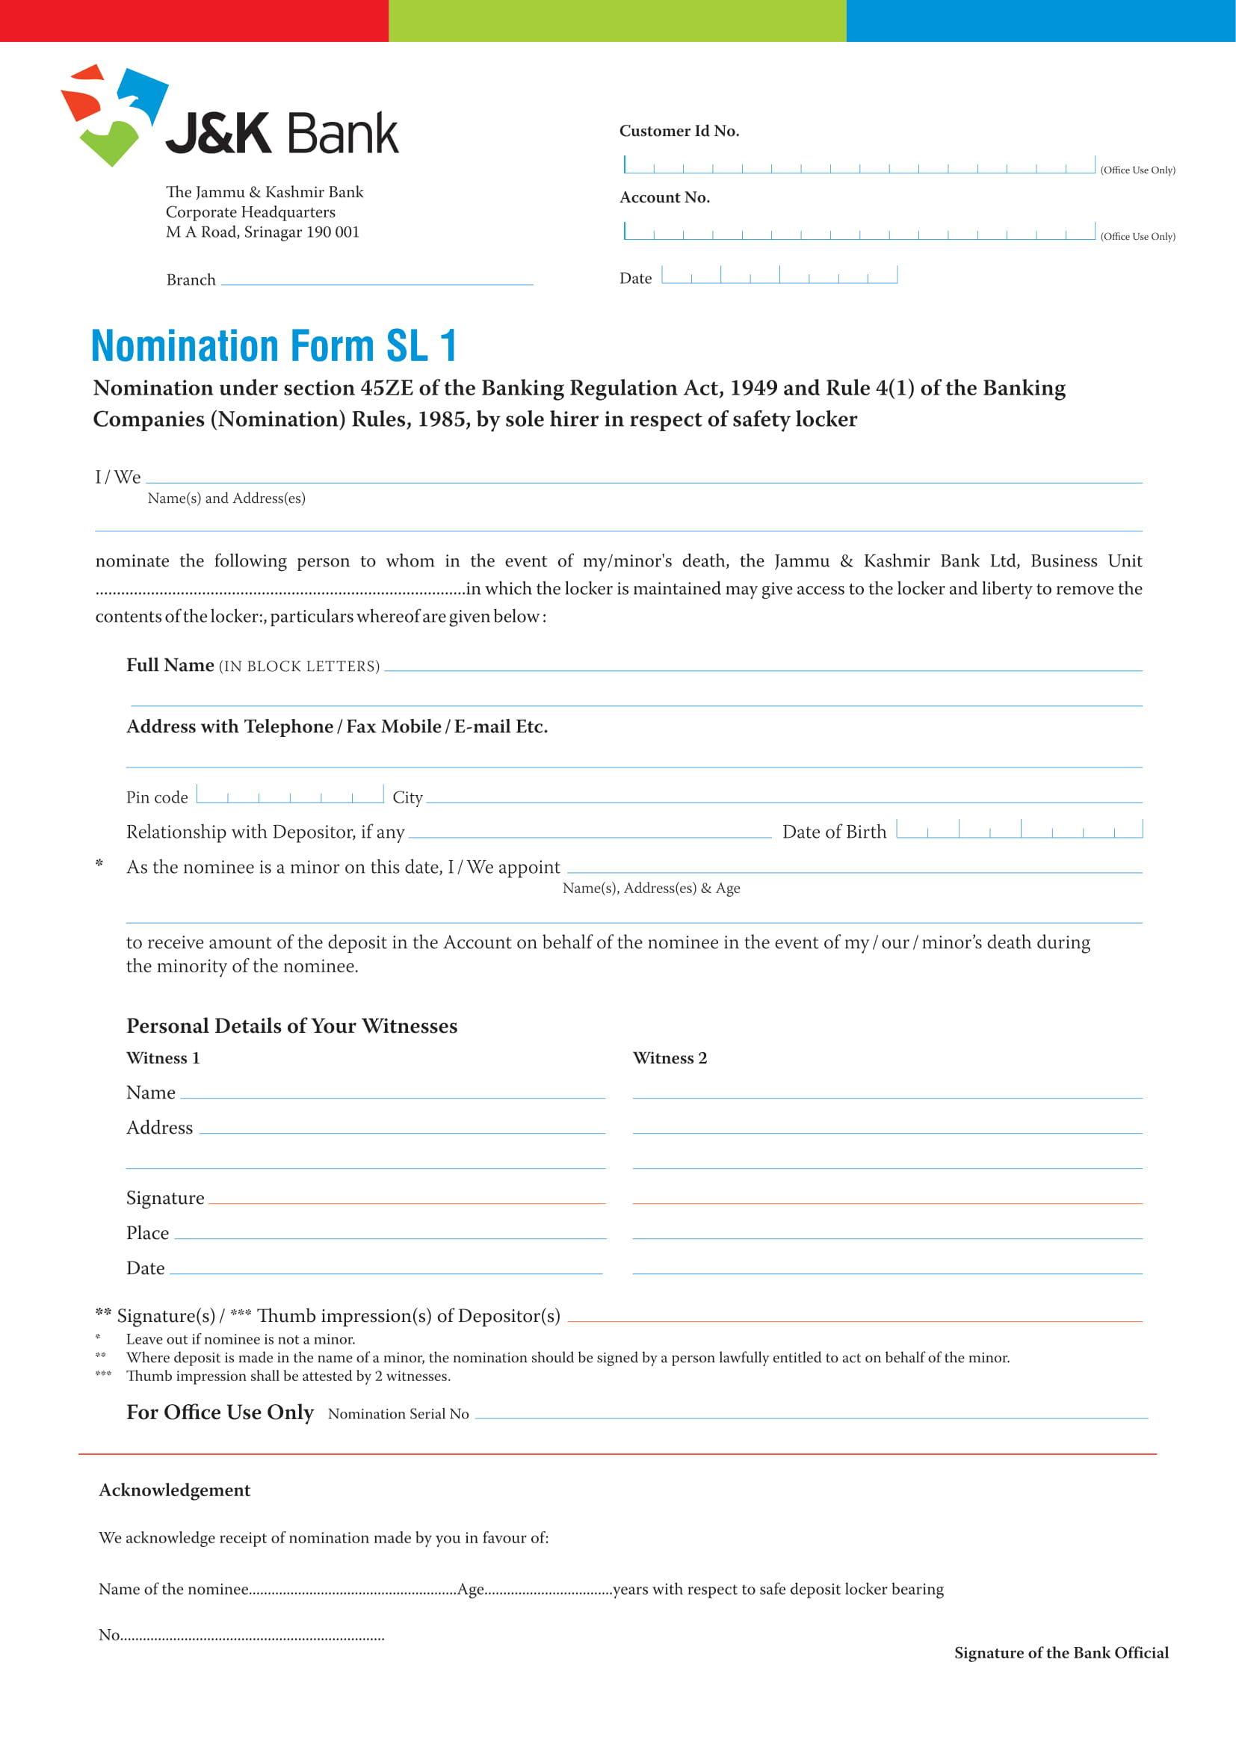

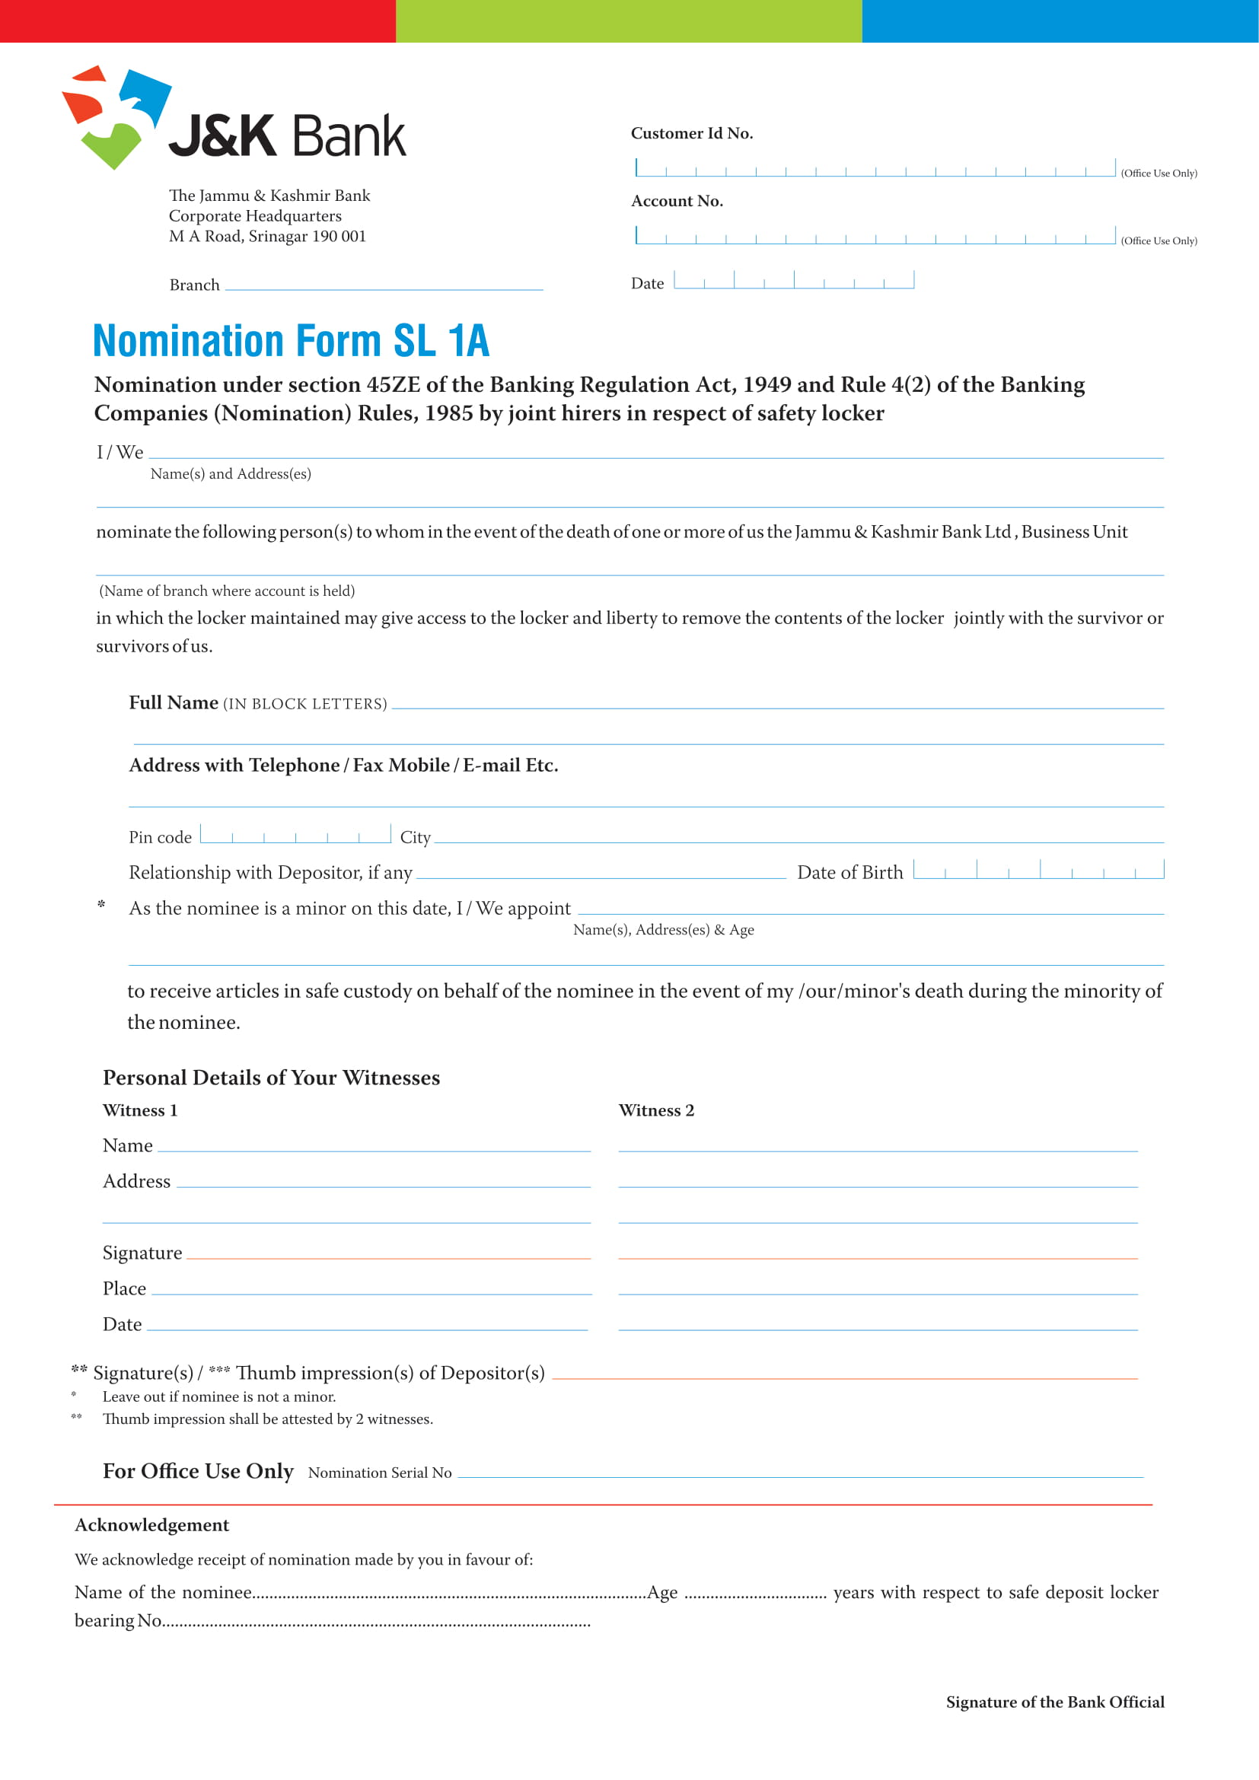

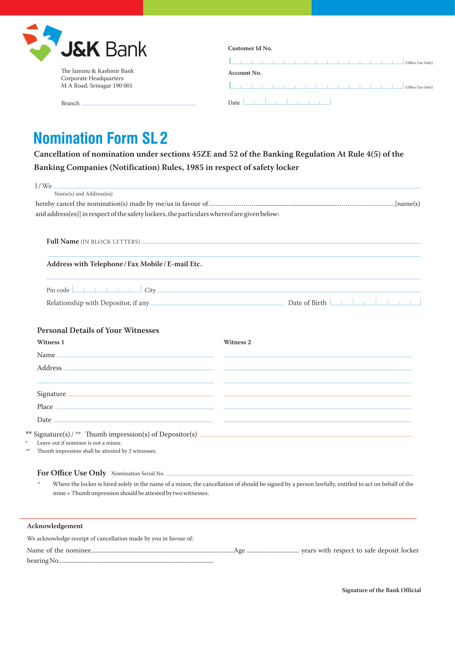

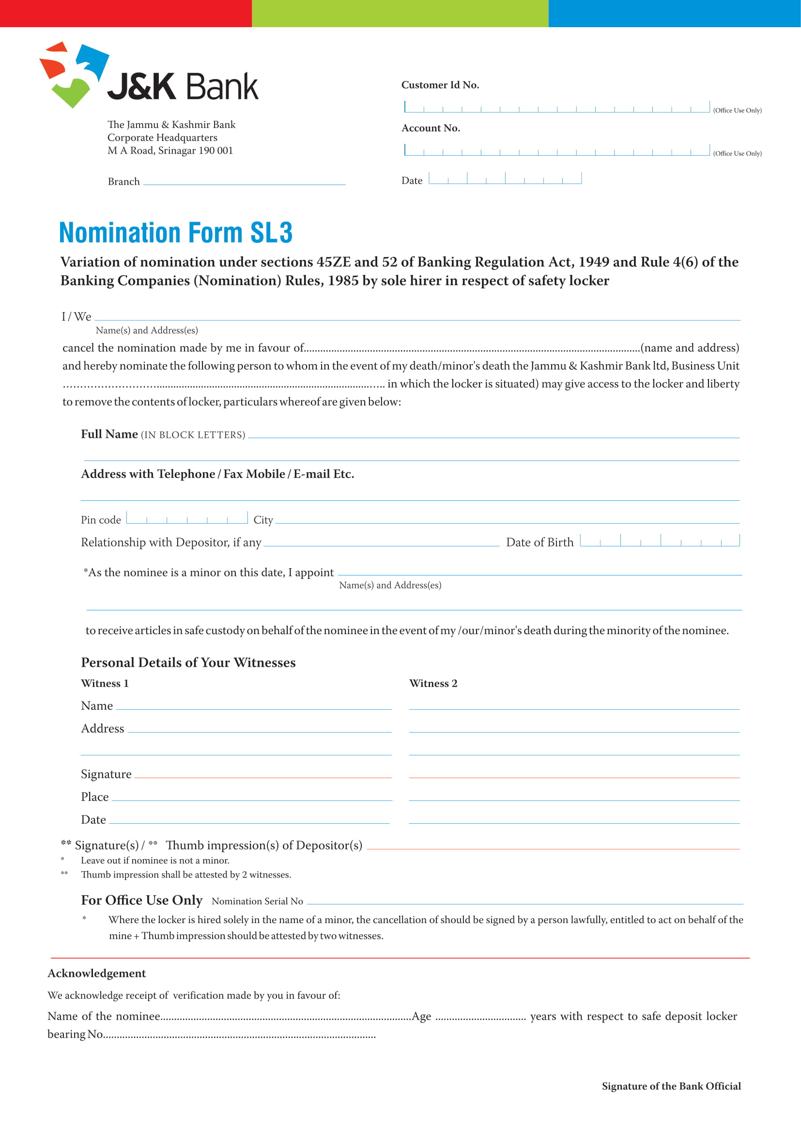

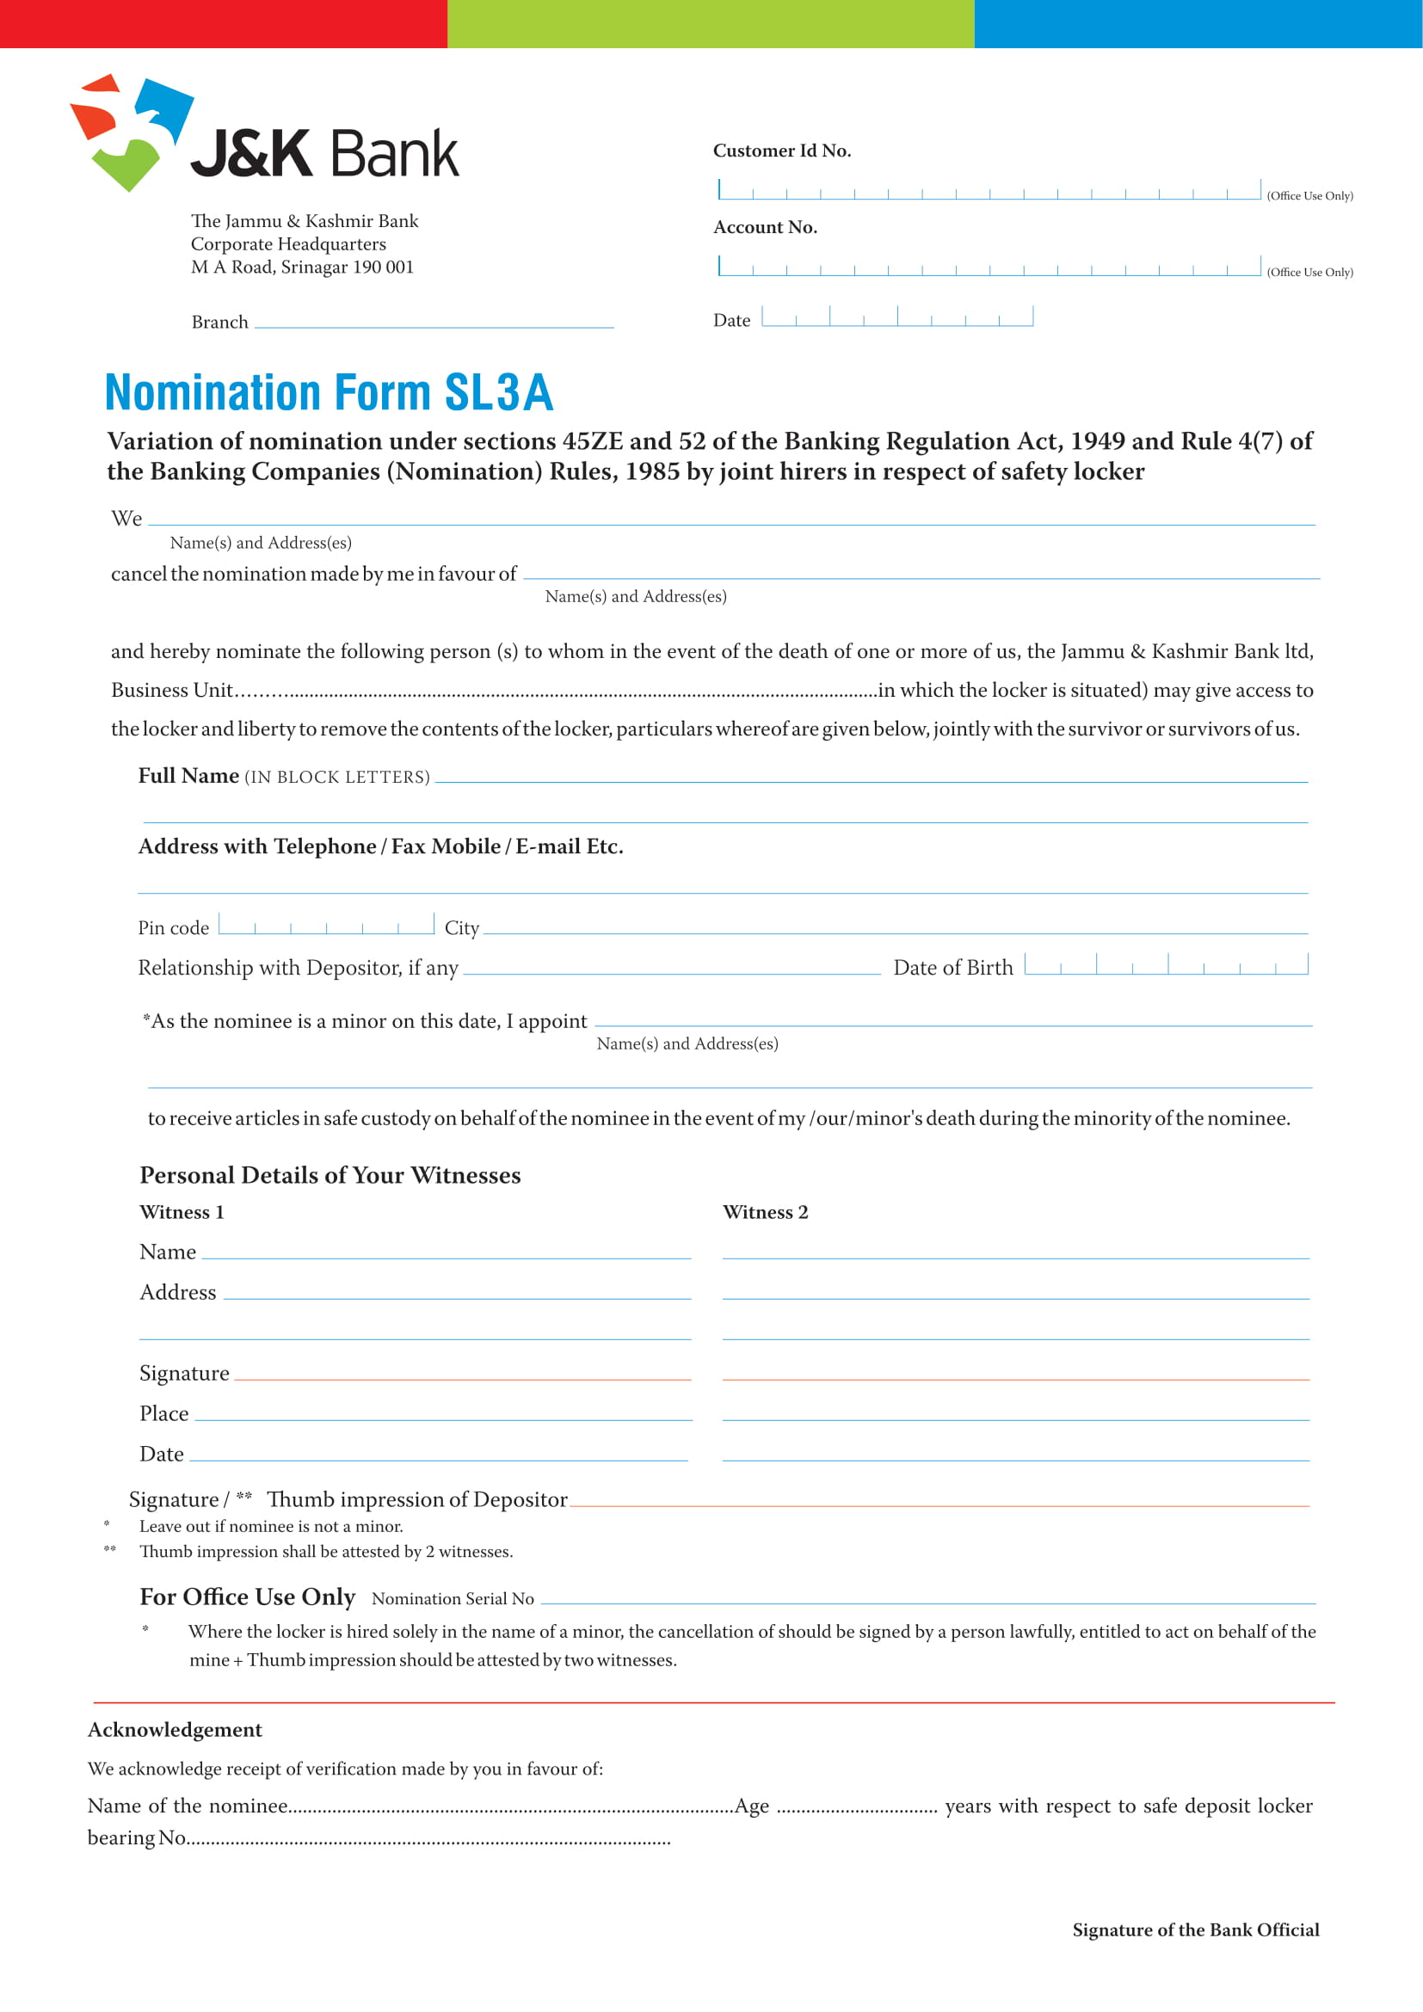

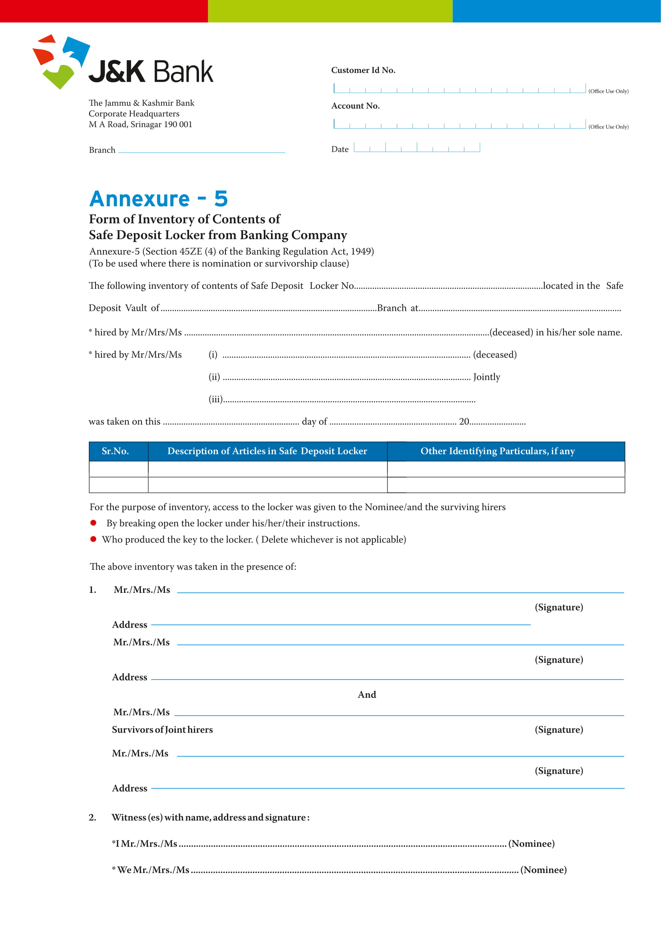

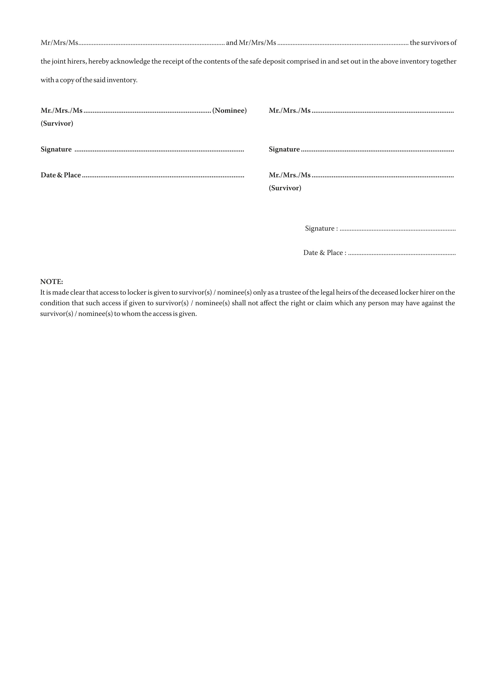

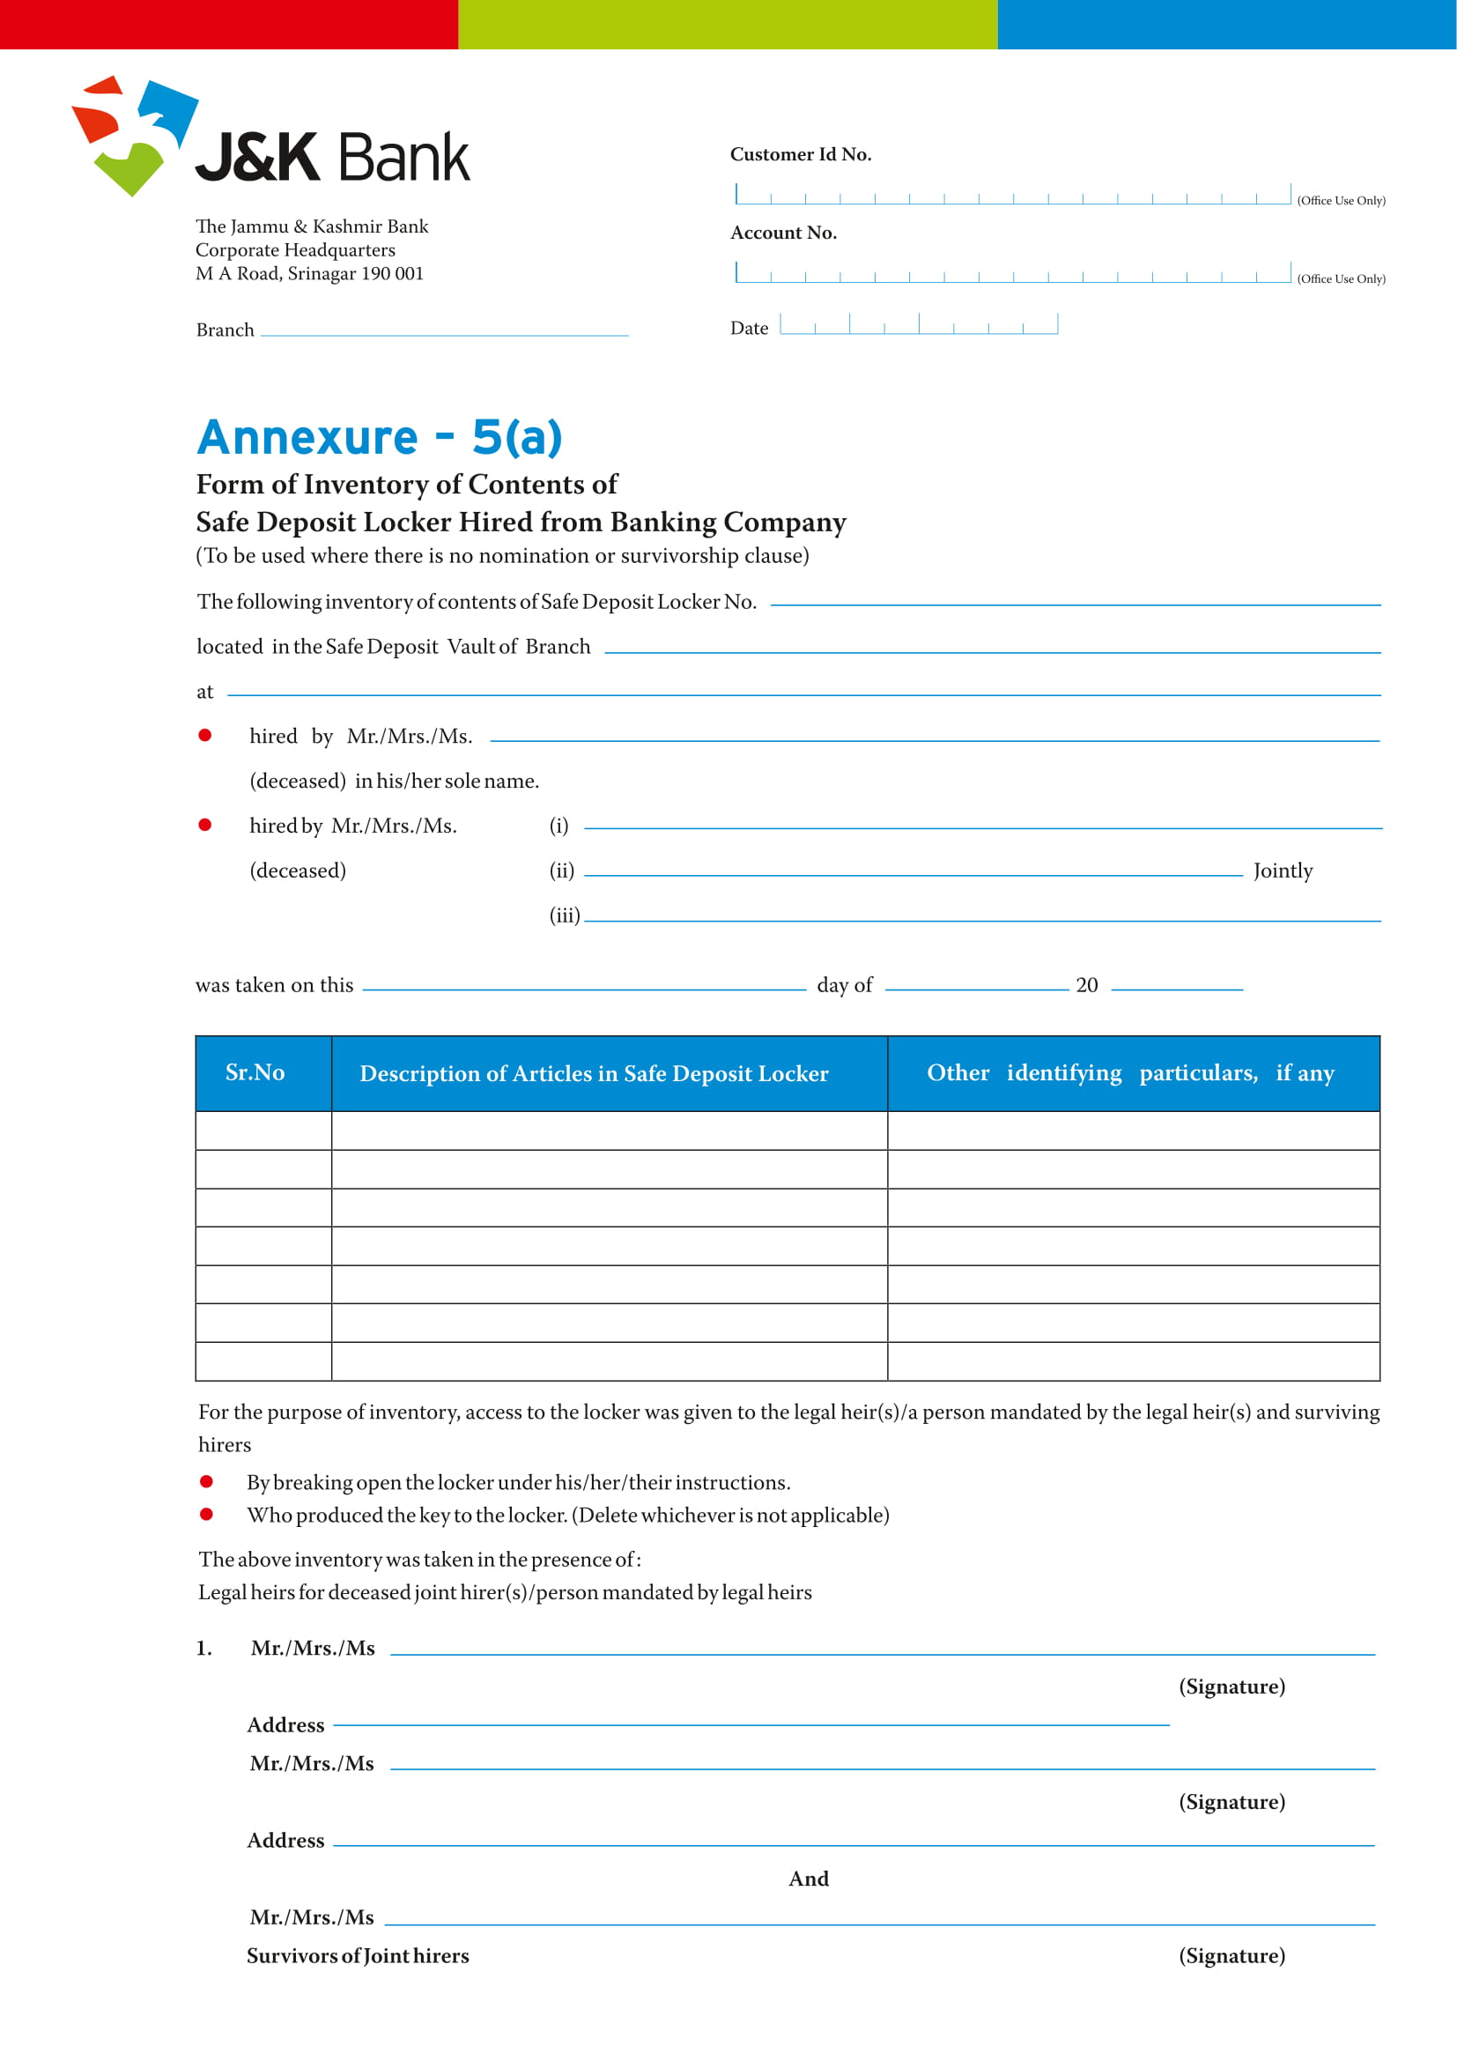

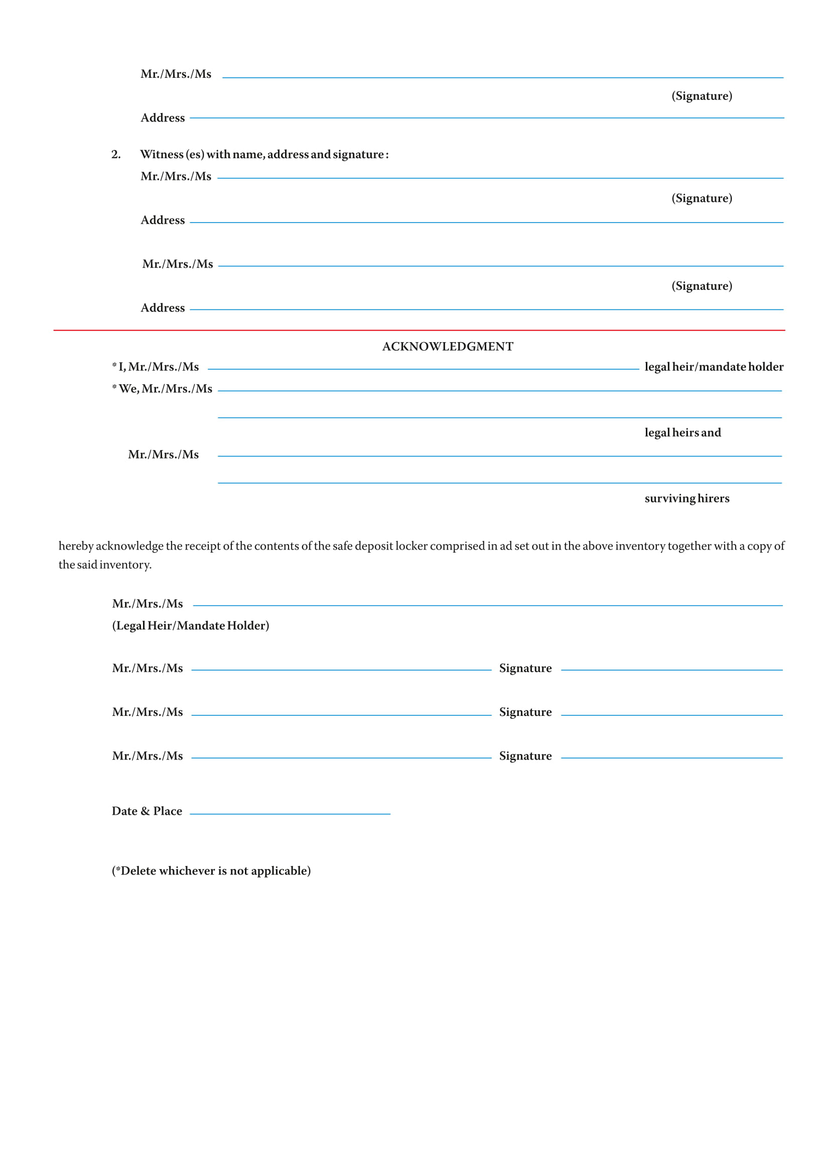

**Annexure-VII**

**Termination Notice**

Dated: _____________

REGISTERED AD

Mr. /Ms ____________________

_________________________

Dear Sir(s)/Madam,

Ref: Your locker no: ________________ with our branch.

This has reference to the Locker Agreement dated ___________ executed by you with the Bank with respect to subject locker number. In this regard, it has been observed that you are not co-operating and/or complying with the terms and conditions of the said locker agreement signed by you with the Bank,

or

You have failed to make payment of rent for a period of _____________ and have failed to respond to our Notice dated _________________ regarding payment of the rent.

..and the Bank has therefore decided to terminate the Locker Agreement and revoke the license provided thereunder to you.

You are therefore hereby called upon to vacate your contents from Locker and handover the keys, password or any other identification mechanism and documents provided by the Bank for opening of the Locker, to the Bank within 30 days of receiving this Notice.

**Thanking you.**

**Yours sincerely**

**Branch Manager**

**Annexure-VIII**

**Auction Notice**

Dated: _____________

REGISTERED AD

Mr. /Ms ____________________

_________________________

Dear Sir(s)/Madam,

Ref: Your locker no: ________________ with our branch.

Please refer to the Termination Notice dated ___________ with respect to Locker No. ____________, licensed to you. That till date, you have not made payment to the Bank of the rent due for the aforesaid Locker No. ________ . That you have also not removed the items and articles from out of the said Locker No. ________. That the Bank was therefore compelled to serve upon you Break Open Notice dated _____________, which was published on ___________ in two newspapers namely ________________ & __________________. That despite said Break Open Notice, you failed to make payment of the rent and other charges due and the Bank was compelled to break open the locker. That the Bank has prepared an inventory of the items found in the said locker No. which is detailed hereunder.

That now in terms of the Locker Agreement and policy of the bank, the Bank is going to Auction and sell the items/articles/ contents found in the aforesaid Locker after 30 days from the date of this Notice.

We therefore hereby give you this notice of thirty days to redeem your property by making payments of the rent, locker breaking charges and other expenses due aggregating to Rs. ______________/- (Rupees _____________________________________________ only) as on ____________, with further interest thereon at agreed/prescribed rate of interest w.e.f. ___________ till the date of payment along with all costs, charges and expenses incurred by the Bank for the realization of same. On your failure to redeem your property by paying our dues within the said period of 30 days, the Bank shall be constrained to Auction and sell the contents of the locker detailed hereunder. The Auction will be held at ____________ on ________________ and the sale consideration amount shall be appropriated towards the dues outstanding in respect of the license of said Locker to you. The remaining amount, if any, shall be paid to you only against proper receipt.

The inventory of the contents is as under:

_________

_________

Thanking you.

Yours sincerely

Branch Manager



The Jammu and Kashmir Bank Limited

Corporate Headquarters, M. A. Road,

Srinagar 190001, Kashmir (J&K)

[www.jkbank.com](http://www.jkbank.com), www.jkbank.net